**Automatic Adjustable Antenna**



**Session (2010-2014)**

## Program:

**Bachelors of Science in Telecommunication**

## Submitted By:

|  |  |
| --- | --- |
| **Usman Zafar** | **(18411)** |
| **Bilal Khan** | **(18354)** |
| **Faisal Shahzad** | **(18357)** |
| **Jamil-udin-Tahir** | **(18370)** |

## Supervised By:

## Engr. Mohsin Shah

## DEPARTMENT OF INFORMATION TECHNOLOGY

**HAZARA UNIVERSITY MANSEHRA**

June 2014

**FINAL APPROVAL**

This is to certify that we have read the thesis titled“ **Automatic Adjustable Antenna**” submitted by Usman Zafar, Bilal Khan, Fasil Shahzad, Jamil-udin-Tahir . It is our judgment that this thesis is of sufficient standard to warrant its acceptance by the Hazara University Mansehra for the BS Degree in Telecommunication.

### Committee:

Supervisor:

Engr. Mohsin Shah

Lecturer

Department of Information

Technology Hazara University Mansehra (Garden Campus).

External Supervisor:

Dated:

Head of Department:

**NOOR-UL-AMEEN**

Head of Department

Information Technology

Hazara University

Mansehra (Garden Campus).

**DEDICATION**

This thesis is dedicated first of all to our parents who have been very supportive and who have provided us with all the support and facilities we require. Without their prayers, this thesis would not have been successful. Secondly, we would like to dedicate our hard work to our supervisor, Engr. Mohsin Shah, who has been a tremendous guideline all through the course of this thesis. We would also like to devote our heartiest appreciation to the Head of Department Information Technology and Telecommunication and all the faculty members who have made this day look brighter for us.

**DECLARATION**

We, hereby declare that this project neither as a whole nor as a part there of has been copied out from any source. It is further declared that we have developed this project and the accompanied report entirely on the basis of our personal efforts made under the sincere guidance of our supervisor. No portion of the work presented in this report has been submitted in the support of any other degree or qualification of this or any other University or Institute of learning, if found we shall stand responsible.

Name: Usman Zafar

Signature:

Name: Bilal Khan

Signature:

Name: Faisal Shahzad

Signature:

Name: Jamil-udin-Tahir

Signature:

**ACKNOWLEDGEMENTS**

We, the associate workers of the project report under study take an initiation with the prestigious name of Almighty Allah, Lord of the worlds who gave us caliber, incentives and courage to complete it with the required goals and within prescribed limit of time factor. Major credit of appreciations along with deep sense of gratefulness goes undoubtedly to our project advisor Mr. Mohsin Shah of Telecommunication Engineering who familiarized us with the initial stages of project at different occasions. Resourcefulness of our advisor was one reason that led this project in finding the real goals.

**PROJECT IN BRIEF**

**Project Title:** Automatic Adjustable Antenna

**Objective:** In Oder To Design An Antenna Which Adjust It Self Automat-

ically

### Undertaken By:

Usman Zafar

Bilal Khan

Faisal Shahzad

Jamil-udin-Tahir

**Supervised By:** Engr. Mohsin Shah

### Starting Month: September 2013

### Ending Month: June 2014

### Software Used: MATLAB

### Environment Used: Windows xp

### System Used: Dell D 610

## DEPARTMENT OF INFORMATION TECHNOLOGY

**HAZARA UNIVERSITY MANSEHRA**

**Contents**

### 1 PROJECT IDEA 1

1.1 Basic Project Narrative . . . . . . . . . . . . . . . . . . . . . . . . . . . . . . 1

1.2 Modules . . . . . . . . . . . . . . . . . . . . . . . . . . . . . . . . . . . . . . 1

1.3 Sensing Module . . . . . . . . . . . . . . . . . . . . . . . . . . . . . . . . . . 2

1.3.1 Horn Antenna . . . . . . . . . . . . . . . . . . . . . . . . . . . . . . . 2

1.3.2 Rotatory Motors . . . . . . . . . . . . . . . . . . . . . . . . . . . . . 3

1.3.3 Dual Relay . . . . . . . . . . . . . . . . . . . . . . . . . . . . . . . . 3 1.3.4 Dual Timer . . . . . . . . . . . . . . . . . . . . . . . . . . . . . . . . 4

1.3.5 ON/OFF Switch . . . . . . . . . . . . . . . . . . . . . . . . . . . . . 4

1.4 Decisions/Logic Control Module: . . . . . . . . . . . . . . . . . . . . . . . . 4

1.4.1 Tasks Implementation . . . . . . . . . . . . . . . . . . . . . . . . . . 4

1.4.2 Problem Solving . . . . . . . . . . . . . . . . . . . . . . . . . . . . . 5

### 2 BASIC ANTENNA CONCEPTS 6

2.1 Antenna . . . . . . . . . . . . . . . . . . . . . . . . . . . . . . . . . . . . . . 6

2.2 Radiation Pattern . . . . . . . . . . . . . . . . . . . . . . . . . . . . . . . . . 6

2.2.1 Radiation Pattern Lobes . . . . . . . . . . . . . . . . . . . . . . . . . 7

2.3 Field Regions . . . . . . . . . . . . . . . . . . . . . . . . . . . . . . . . . . . 7

2.4 Radiation Power Density . . . . . . . . . . . . . . . . . . . . . . . . . . . . . 8

2.5 Radiation Intensity . . . . . . . . . . . . . . . . . . . . . . . . . . . . . . . . 9

2.6 Directivity . . . . . . . . . . . . . . . . . . . . . . . . . . . . . . . . . . . . . 9

2.7 Antenna Efficiency . . . . . . . . . . . . . . . . . . . . . . . . . . . . . . . . 10

2.7.1 Standing Wave Ratio . . . . . . . . . . . . . . . . . . . . . . . . . . . 11

2.7.2 Return Loss . . . . . . . . . . . . . . . . . . . . . . . . . . . . . . . . 11

2.8 Gain . . . . . . . . . . . . . . . . . . . . . . . . . . . . . . . . . . . . . . . . 11

2.9 Efficiency . . . . . . . . . . . . . . . . . . . . . . . . . . . . . . . . . . . . . 12

2.10 Reciprocity . . . . . . . . . . . . . . . . . . . . . . . . . . . . . . . . . . . . 12

2.11 Bandwidth . . . . . . . . . . . . . . . . . . . . . . . . . . . . . . . . . . . . . 12

2.12 Polarization . . . . . . . . . . . . . . . . . . . . . . . . . . . . . . . . . . . . 13

2.13 Types Of Antenna . . . . . . . . . . . . . . . . . . . . . . . . . . . . . . . . 13

2.13.1 Corner Reflector . . . . . . . . . . . . . . . . . . . . . . . . . . . . . 13

2.13.2 Yagi . . . . . . . . . . . . . . . . . . . . . . . . . . . . . . . . . . . . 14

2.13.3 Arrays . . . . . . . . . . . . . . . . . . . . . . . . . . . . . . . . . . . 15

2.13.4 Half Wave Dipole Antenna . . . . . . . . . . . . . . . . . . . . . . . . 16

2.13.5 The Folded Dipole Antenna . . . . . . . . . . . . . . . . . . . . . . . 17

2.13.6 Loop Antenna . . . . . . . . . . . . . . . . . . . . . . . . . . . . . . . 17

2.14 Horn Antenna . . . . . . . . . . . . . . . . . . . . . . . . . . . . . . . . . . . 18

2.14.1 Types Of Horn Antennas . . . . . . . . . . . . . . . . . . . . . . . . . 18

### 3 STEPPING MOTORS AND TYPES 20

3.1 Introduction . . . . . . . . . . . . . . . . . . . . . . . . . . . . . . . . . . . 20

3.2 Variable Reluctance Motors . . . . . . . . . . . . . . . . . . . . . . . . . . . 20

3.3 Unipolar Motors . . . . . . . . . . . . . . . . . . . . . . . . . . . . . . . . . 21

3.4 Bipolar Motors . . . . . . . . . . . . . . . . . . . . . . . . . . . . . . . . . . 23

3.5 Bifilar Motors . . . . . . . . . . . . . . . . . . . . . . . . . . . . . . . . . . . 24

3.6 Multiphase Motors . . . . . . . . . . . . . . . . . . . . . . . . . . . . . . . . 25

### 4 STEPPER MOTOR AND OPERATION 27

4.1 Other Stepper Motors . . . . . . . . . . . . . . . . . . . . . . . . . . . . . . 27

4.2 Interleaving One Wire . . . . . . . . . . . . . . . . . . . . . . . . . . . . . . 28

4.2.1 Counter Clockwise Motion . . . . . . . . . . . . . . . . . . . . . . . . 28

4.3 Clockwise Motion. . . . . . . . . . . . . . . . . . . . . . . . . . . . . . . . . 31

4.4 Interleaving Two Wires . . . . . . . . . . . . . . . . . . . . . . . . . . . . . 34

4.4.1 Counter Clockwise Motion . . . . . . . . . . . . . . . . . . . . . . . . 34

4.4.2 Clockwise Motion . . . . . . . . . . . . . . . . . . . . . . . . . . . . . 37

### 5 MATLAB AND INTERFACES 40

5.1 Introduction . . . . . . . . . . . . . . . . . . . . . . . . . . . . . . . . . . . . 40

5.2 The Parallel Port . . . . . . . . . . . . . . . . . . . . . . . . . . . . . . . . . 40

5.3 Parallel Connector Pin Out . . . . . . . . . . . . . . . . . . . . . . . . . . . 40

5.4 Parallel Printer Cable . . . . . . . . . . . . . . . . . . . . . . . . . . . . . . . 41

5.5 Parallel Port Test Plugs . . . . . . . . . . . . . . . . . . . . . . . . . . . . . 42

5.6 The Parallel Port And Matlab. . . . . . . . . . . . . . . . . . . . . . . . . . 42

5.7 Digital I/O Line Values . . . . . . . . . . . . . . . . . . . . . . . . . . . . . 46

5.7.1 Writing Digital Values . . . . . . . . . . . . . . . . . . . . . . . . . . 46

5.7.2 Rules For Writing Digital Values . . . . . . . . . . . . . . . . . . . . 47

5.7.3 Reading Digital Values . . . . . . . . . . . . . . . . . . . . . . . . . . 47

5.7.4 Rules For Reading Digital Values . . . . . . . . . . . . . . . . . . . . 47

### 6 PARALLEL PORT INTERFACES 49

6.1 Stepper Motors And Drive Methods . . . . . . . . . . . . . . . . . . . . . . . 49

6.2 Stepper Motor Interfacing Circuit . . . . . . . . . . . . . . . . . . . . . . . . 51

6.3 Project Circuit . . . . . . . . . . . . . . . . . . . . . . . . . . . . . . . . . . 55

6.4 Schematic And How It Works . . . . . . . . . . . . . . . . . . . . . . . . . . 56

### 7 IR COMMUNICATION 58

7.1 Infrared . . . . . . . . . . . . . . . . . . . . . . . . . . . . . . . . . . . . . . 58

7.2 Natural Infrared . . . . . . . . . . . . . . . . . . . . . . . . . . . . . . . . . . 59

7.3 IR Communication Basics . . . . . . . . . . . . . . . . . . . . . . . . . . . . 59

7.4 Equipments used in our designed . . . . . . . . . . . . . . . . . . . . . . . . 60

7.5 Transmitter Module . . . . . . . . . . . . . . . . . . . . . . . . . . . . . . . . 60

7.6 IR Receiver Module . . . . . . . . . . . . . . . . . . . . . . . . . . . . . . . . 61

7.7 C 945 Transistor (NPN) . . . . . . . . . . . . . . . . . . . . . . . . . . . . . 62

7.8 Tune Generator Module . . . . . . . . . . . . . . . . . . . . . . . . . . . . . 63

7.9 Pin-Wise Functioning OF IC555 Timer . . . . . . . . . . . . . . . . . . . . . 64

### 8 CONCLUSION 66

8.1 Introduction . . . . . . . . . . . . . . . . . . . . . . . . . . . . . . . . . . . . 66

8.2 Using Simple Motor And Stepper Motor . . . . . . . . . . . . . . . . . . . . 66

8.2.1 Matlab Code . . . . . . . . . . . . . . . . . . . . . . . . . . . . . . . 67

8.2.2 Circuit For Stepper Motor Control . . . . . . . . . . . . . . . . . . . 70

8.3 Using Stepper Motor Only. . . . . . . . . . . . . . . . . . . . . . . . . . . . . 70

8.3.1 Using Single Stepper Motor. . . . . . . . . . . . . . . . . . . . . . . . 71

8.4 Using Two Stepper Motors. . . . . . . . . . . . . . . . . . . . . . . . . . . . 72

**List of Figures**

|  |  |
| --- | --- |
| 1.1 Modules . . . . . . . . . . . . . . . . . . . . . . . . . . . . . . . . . . . . . . | 1 |
| 1.2 Sensing Module . . . . . . . . . . . . . . . . . . . . . . . . . . . . . . . . . . | 2 |
| 1.3 Rotatory Motors . . . . . . . . . . . . . . . . . . . . . . . . . . . . . . . . . | 3 |
| 1.4 Dual Relay . . . . . . . . . . . . . . . . . . . . . . . . . . . . . . . . . . . . | 3 |
| 1.5 ON/OFF Switch . . . . . . . . . . . . . . . . . . . . . . . . . . . . . . . . . | 4 |
| 2.1 E-Field and H-Field Composition in Horn Antenna . . . . . . . . . . . . . . | 7 |
| 2.2 (a) Radiation lobes And Beam Widths Of An Antenna Pattern. . . . . . . . | 7 |
| 2.3 (b) Linear Plot Of Power Pattern And Its Associated And Beam Widths . . | 8 |
| 2.4 Field Regions Of An Antenna . . . . . . . . . . . . . . . . . . . . . . . . . . | 8 |
| 2.5 Reference Terminals And Losses Of An Antenna . . . . . . . . . . . . . . . . | 10 |
| 2.6 Electric And Magnetic Field Component . . . . . . . . . . . . . . . . . . . . | 13 |
| 2.7 Corner Reflector antennas . . . . . . . . . . . . . . . . . . . . . . . . . . . . | 14 |
| 2.8 The Yagi antenna (a) three elements and (b) multiple elements . . . . . . . | 14 |
| 2.9 A Yagi antenna horizontalplane pattern . . . . . . . . . . . . . . . . . . . . . | 15 |
| 2.10 A typical vertical array using folded dipoles . . . . . . . . . . . . . . . . . .  2.11 Vertical-plane radiation patterns for (a) single half-wave dipole, (b) two- | 15 |
| element array, and (c) three element array . . . . . . . . . . . . . . . . . . . | 16 |
| 2.12 Half Wave Dipole Antenna . . . . . . . . . . . . . . . . . . . . . . . . . . . . | 16 |
| 2.13 Half Wave Folded Dipole . . . . . . . . . . . . . . . . . . . . . . . . . . . . . | 17 |
| 3.1 Variable Reluctance Motor . . . . . . . . . . . . . . . . . . . . . . . . . . . . | 21 |
| 3.2 Unipolar Motor . . . . . . . . . . . . . . . . . . . . . . . . . . . . . . . . . . | 23 |
| 3.3 Bipolar Motor . . . . . . . . . . . . . . . . . . . . . . . . . . . . . . . . . . . | 24 |
| 3.4 Bifilar Motor . . . . . . . . . . . . . . . . . . . . . . . . . . . . . . . . . . . | 25 |
| 3.5 Multiphase Motor . . . . . . . . . . . . . . . . . . . . . . . . . . . . . . . . . | 26 |
| 5.1 Centronics Pin Out . . . . . . . . . . . . . . . . . . . . . . . . . . . . . . . . | 41 |
| 5.2 Norton Test Plug . . . . . . . . . . . . . . . . . . . . . . . . . . . . . . . . . | 42 |
| 5.3 Check It Test Plug . . . . . . . . . . . . . . . . . . . . . . . . . . . . . . . . | 42 |
| 6.1 Stepper Motor Interfacing Circuit . . . . . . . . . . . . . . . . . . . . . . . . | 51 |
| 6.2 Stepper Motor Drive Circuit Full Stepping 4 Phase Unipolar Drive . . . . . . | 54 |
| 6.3 Basic Stepper Motor . . . . . . . . . . . . . . . . . . . . . . . . . . . . . . . | 55 |
| 6.4 Project Circuit Diagram . . . . . . . . . . . . . . . . . . . . . . . . . . . . . | 56 |

7.1 IR Transmitter . . . . . . . . . . . . . . . . . . . . . . . . . . . . . . . . . . 61

7.2 IR Receiver . . . . . . . . . . . . . . . . . . . . . . . . . . . . . . . . . . . . 61

8.1 Sensing Module . . . . . . . . . . . . . . . . . . . . . . . . . . . . . . . . . . 66

8.2 Circuit For Stepper Motor Control . . . . . . . . . . . . . . . . . . . . . . . 70

8.3 Using Single Stepper Motor . . . . . . . . . . . . . . . . . . . . . . . . . . . 71 8.4 Using Single Stepper Motor . . . . . . . . . . . . . . . . . . . . . . . . . . . 71

8.5 Using Two Stepper Motors . . . . . . . . . . . . . . . . . . . . . . . . . . . . 72

**Chapter 1 PROJECT IDEA**

# 1.1 Basic Project Narrative

In all fields of engineering, many different solutions can be presented for the same problem. The goal of an engineer is twofold. The first and most distinct goal is to identify and design possible solutions to a complex problem. The second goal, which is perhaps less obvious, is to choose which solution is best suitable to most economically meet project specifications. This project deals with the general field of Electrical Engineering and Control Engineering. **“The basic theme of our project is to controlling the position and direction of an antenna using some kind of electrical device which will do the sensing task to intercept the incoming signal, then finding the maximum signal strength coordinates around the** 360◦ **circumference and then move the output steppermotor to that position”.**

# 1.2 Modules

For our convenience, we have divided our project in 3 different Modules.

These modules are mentioned as under:

### 1 Sensing Module

### 2 Decision/Logic Control Module

### 3 Adjustment Module

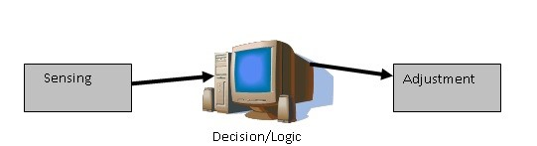

Figure 1.1: Modules

1

*1.3 Sensing Module*

These three modules are selected on the basis of flow of making of our project, which means that the former module is essential for the latter one.

# 1.3 Sensing Module

The sensing Module is the first and most important module in our project. The working mechanism and level of accuracy of other modules in our project are strongly dependent on this module.This module mainly interacts with the air for intercepting the incoming signal and thus providing the input signal to the Decision Module. The function of this module is to sense and search the Radio Frequency signal (incoming) around the 360◦ circumference.

This module is mainly consisting of

### 1. Horn Antenna

### 2. Rotatory Motor

### 3. Dual Relays

### 4. Dual Timers

### 5. ON/OFF Switch

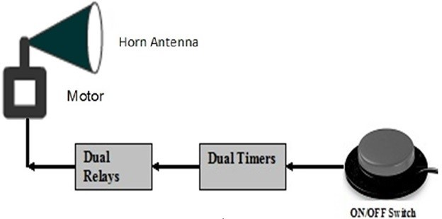

Figure 1.2: Sensing Module

# Explanation

Each component of this module is explained one by one.

## 1.3.1 Horn Antenna

The component of the sensing module that interacts with environment is the Horn Antenna.As shown in Figure 1 the Horn antenna is revolving in circular direction. This movement may be in Clockwise direction or in anticlockwise direction but this point is worth

*1.3 Sensing Module*

mentioning here that the Horn antenna will intercept the incoming signal while it is circulating in clockwise direction.We introduced the anticlockwise movement for the sake of feed wire, which gets tie up around the base of the antenna while it is revolving in clockwise direction. This antenna can complete one cycle in clockwise direction up to 2 seconds. During these 2 seconds this antenna will capture the incoming signal. [2].

## 1.3.2 Rotatory Motors

The Horn antenna is welded to this Rotatary motor.As shown in the figure 1.2, this motor provides a base point for the Horn antenna. This motor operates on 12 volts power supply, however it can operate on lower voltages but then its speed of revolution will be very much slow. Thus, the speed of this motor depends on the level of input signal.

Also, this motor is mainly design for circulating in clockwise direction but we can rotate it in anticlockwise direction but reversing the polarity of the input voltage.

This motor is actually a door mirror motor and we got it from a warehouse.

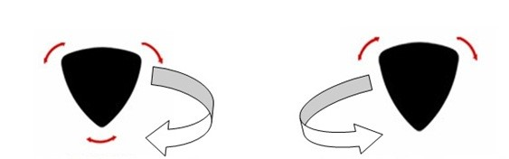

**clockwise movement anticlockwise movement**

Figure 1.3: Rotatory Motors

## 1.3.3 Dual Relay

The current signal in forward and in reverse direction is controlled by this dual functioning relay.This Dual Relay is actually an electrically operated switch. Current flowing through the coil of the relay creates a magnetic field which attracts lever and changes the switch contacts. The coil current can be on or off so relays have two switch positions and they are double throw (changeover) switches.

The main advantage of this relay is that it can switch AC and DC while on the other hand a transistor can switch only DC. Also this dual relay can switch high voltages

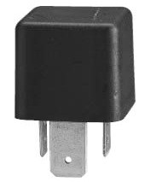

Figure 1.4: Dual Relay

*1.4 Decisions/Logic Control Module:*

## 1.3.4 Dual Timer

The current for one complete revolution in either direction is allowed by this Dual timer.This timer is inserted between the ON/OFF switch and the relay in order to control the flow of current to the Rotatary Motor in terms of duration. This Dual Timer is actually consists of two separate timers, one is connected for clockwise movement and the second one is connected for the anticlockwise movement and each timer is capable of allowing current up to 30 Seconds in either direction[3].

As mentioned earlier, our Rotatary Motor complete one cycle in about 2 seconds, so we have adjusted this timer up to 2 seconds in order to get our desired time of revolution.

## 1.3.5 ON/OFF Switch

The ON/OFF Switch allows the dipole antenna to start revolution and control the flow of current. This switch is basically a human interface unit and is controlled by us. It is a 3 level switch which means that[4]

### i. When we want movement in clockwise direction, we press it forward.

### ii. When we want movement in anticlockwise direction, we press it backward. iii. For OFF condition, we keep the level of the switch in the middle.

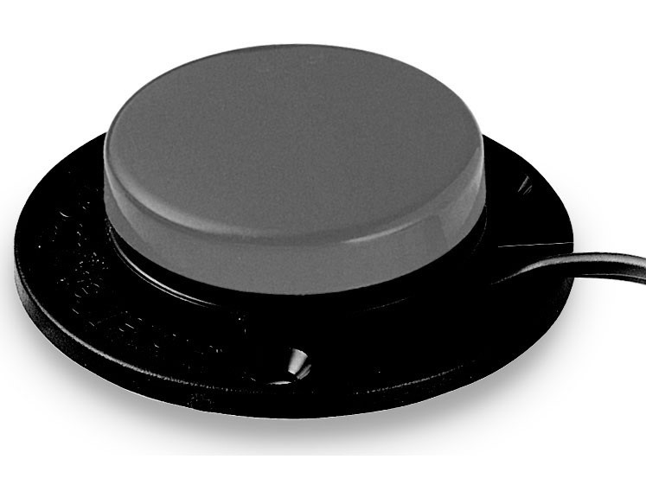

Figure 1.5: ON/OFF Switch

# 1.4 Decisions/Logic Control Module:

This is basically a software base module and it provides the intermediate connection between sensing module and the adjustment module. In the beginning of our project, we have two options for implementation of this module and we used both of them for it.

### i. The first option is to use a Matlab application, and completing the decision module. ii. The second option is to use DSP-Kit for implementation of this module.

## 1.4.1 Tasks Implementation

The key tasks of this module in our project are:

### i. Storing the Incoming Signal in the memory unit of the computer.

### ii. Finding the index (Angle) where the maximum signal level has occurred in

*1.4 Decisions/Logic Control Module:*

### the captured signal.

To achieve the above mentioned task, the Matlab Application does all the necessary processing for us.

## 1.4.2 Problem Solving

The level of accuracy of our project is based upon this module, thats why we are trying our level best to develop this module at optimum level. The main problem in this module was the interface between the dipole antenna and the computer. It took a lot of time and finally we agreed to get this interface using the soundcard of the computer.The sound card enables us to get the signal from the antenna and store it the memory of the computer. Then implementing some basic logic of getting the maximum value in Matlab, we get our desire maximum signal strength and the angle at which it occurs.

The below figure shows the point at which maximum level of signal occurs.

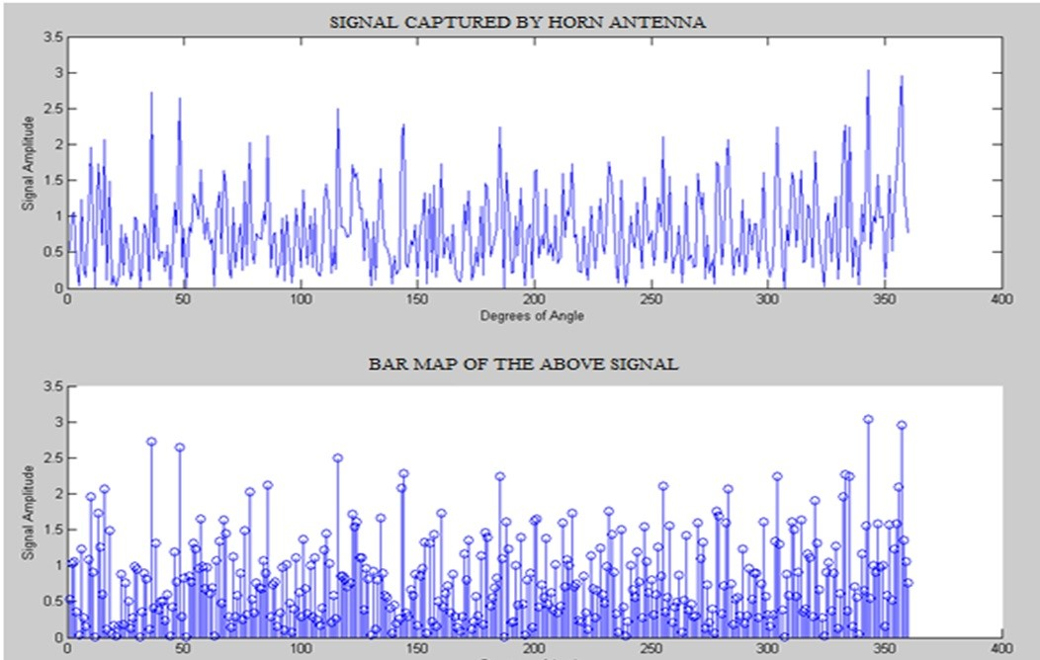

**Chapter 2**

**BASIC ANTENNA CONCEPTS**

# 2.1 Antenna

An antenna is defined by Webster’s Dictionary as **“ a usually metallic device (as a rod or wire) for radiating or receiving radio waves”.** In the same way, according to IEEE standards definitions of Terms for Antennas as given by Stutzman and Thiele[4] **“The antenna or aerial as a means for radiating or receiving radio waves”**. An antenna is a transitional structure between free space and a transmission line, usually made from a conducting material, which has been designed to have a shape and size such that it will radiate electromagnetic power in an efficient manner. The transmission line is basically a coaxial feed, strip line, micro strip or a waveguide to transport energy from the transmitter to the antenna, then transmitting antenna send the electromagnetic waves via air interface at receiving antenna. In other words, transmitting antenna create disturbance in the form of electromagnetic waves towards receiving antenna to completely understand the language of radio waves.

A basic parts of antenna system consists of source, transmission line/feeder and Antenna. The source, the transmission line or feeder comprises of characteristic impedance Zo, and the antenna is characterized by a load connected to the feeder. The load resistance represent the dielectric (depends upon material) and conduction losses (thermal collision of electrons) with the antenna structure. The radiation resistance is actually the radiation of electromagnetic energy from the antenna.

# 2.2 Radiation Pattern

Radiation pattern is graphical representation of radiation of electromagnetic energy as a function of space coordinates. As name suggests, radiation pattern actually tells us about the behavior of propagation of energy in some particular direction. If the direction of propagation energy in all direction uniformly then that type of antenna is known as Isotropic Antenna .Similarly, an antenna which radiates its energy in some given direction, then it is said to be **“Directional Antenna”**.Antenna radiation patterns classify into two ways, the elevation pattern and azimuth pattern. Elevation pattern/E-plane is defined as

6

*2.3 Field Regions*

“the plane containing the electric field vector and the direction of maximum radiation, and the azimuth pattern/H-Plane is defined as “the plane containing the magnetic field vector and the direction of maximum radiation. E-field and H-field components are clearly demonstrated in Figure 2.1 shown below.

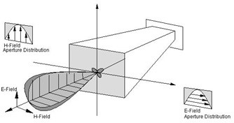

Figure 2.1: E-Field and H-Field Composition in Horn Antenna

## 2.2.1 Radiation Pattern Lobes

Radiation pattern have various parts to send the electromagnetic energy. These parts are divided on the basis of their strength of energy. This division of parts is also known as “radiation lob”. So, radiation lobe subdivided into major lobe or main/principle, minor, side and back lobes. Major or principle lobe defines as “the radiation lobe contacting the direction of maximum radiation”. The lobe other than major lobe is known as minor lobe. The side lobe is basically the unwanted lobe in any direction other than the intended lobe. A back lobe is a radiation lobe opposite to the major lobe or on 180◦ phase shift from the principle lobe.Beam widthis defined as “an angular separation of the radiation pattern for major lobe”. Half-power beam width(HPBW) is an angular beam width at half power level or -3db beam width. A computer generated 3-Dimension polar plot and 2- Dimensional linear plot is exhibited in[5]

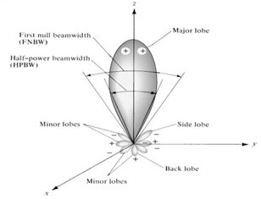

Figure 2.2: (a) Radiation lobes And Beam Widths Of An Antenna Pattern.

# 2.3 Field Regions

As antenna is a transitional element between guided and unguided media. When antenna transmits electromagnetic waves in space, it is usually divided into three main regions: ( a )

*2.4 Radiation Power Density*

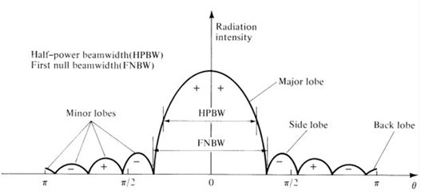

Figure 2.3: (b) Linear Plot Of Power Pattern And Its Associated And Beam Widths Fig 2.3 3D and 2D Radiation Pattern

reactive near field, (b) radiating near field (Fresnel) (c) far-field regions (Fraunhofer) as shown in Figure 2.4. There are certain criteria for the distribution of field regions which are also mentioned in the figure given below.

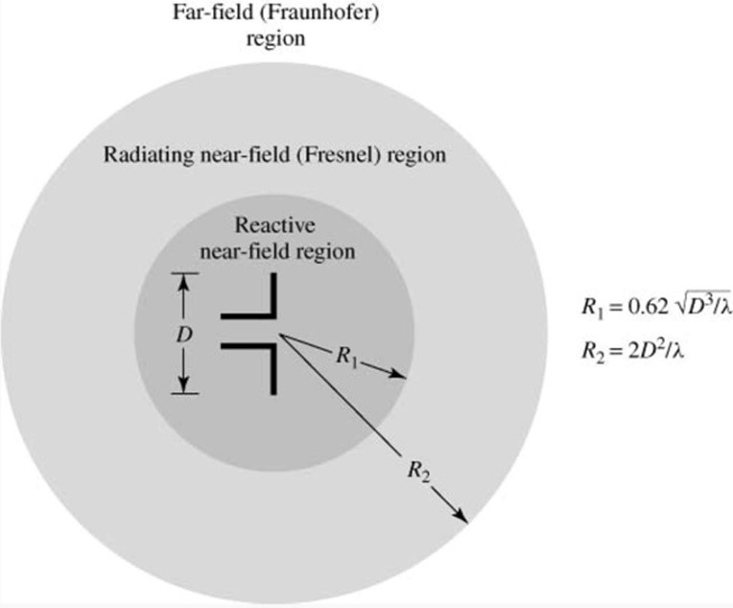

Figure 2.4: Field Regions Of An Antenna

Reactive near-field region is the region in the vicinity of antenna where highly reactive and non-propagating or stored energy is present and the reason is that phase of Electric field component and Magnetic Filed components are totally different. So, highly stored energy is exhibited in the near field region. Main function of antenna is to transfer maximum energy into space rather to store the energy.Radiating near-field region does not contain reactive field component because phases of E and H field are almost same. Angular field distribution/pattern is dependent upon the distance from the antenna.Far-field region contain E field and H field component that are completely in phase. So, radiating power is real and reactive power is almost zero. Angular field distribution is independent of the distance from the antenna. That’s why spherical wave fronts and wave impedance is real.

# 2.4 Radiation Power Density

Electromagnetic energy is used to transport the signal through a wireless medium. As we know that, electromagnetic energy is the combination of electric field intensity and

*2.6 Radiation Intensity*

magnetic field intensity. So, radiation power density is represented by a Poynting vector which is defined as

*W* = *E* ∗ *H* (2.1)

W = Poynting Vector ( W/m 2)

E = Electric field intensity ( W/m 2) H = Magnetic Field Intensity ( W/m 2)

# 2.5 Radiation Intensity

“The power radiated from an antenna per unit solid angle” is called the radiation intensity denoted by U (watts per steridan or per square degree). As we know that, Radiation intensity only exits in far field calculation, therefore it can also be obtain by multiplying the radiation density by the square of the distance. So, mathematically it can be written as

*U* = *r*2*Wrad* (2.2)

Where,

U = radiation intensity (W/unit solid angle)

Wrad= radiation density ( W/m 2)

Thus the total power is easily obtained by integrating the radiation intensity over the entire solid angle of 4*π*

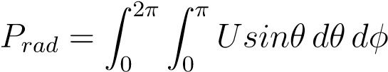 (2.3)

where

*d*Ω = *elementof solid angle* = sin*θ dθ dφ*

# 2.6 Directivity

Directivity is the basic antenna parameter .Directivity is used to measure the directionality of antenna .If an antenna radiates equally in all direction then we say that its directivity is zero. It is defined as “The ratio of the radiation intensity in a given direction from the antenna to the radiation intensity averaged over all directions”. “Directivity of an isotropic source is unity since its power is radiated equally well in all direction. For all other sources, the maximum directivity will always be greater than unity”.Directivity is the function of angle, so its angular variation is defined by its radiation pattern. Thus

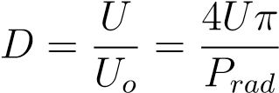 (2.4)

*2.7 Antenna Efficiency*

D = directivity ( dimensionless )

U = radiation intensity (W/unit solid angle)

*U*◦ = radiation density of isotropic source ( W/m 2)

# 2.7 Antenna Efficiency

Antenna efficiency depends upon different type of efficiencies which can be demonstrated in Figure 2.3. The total antenna efficiency *e*◦ is used to take all type of losses at the input terminal as well as within the structure of the antenna. Mainly antenna efficiency depends upon two factors.

1. Reflections because of the mismatch between the transmission line and the antenna.
2. Conduction and Dielectric Losses.

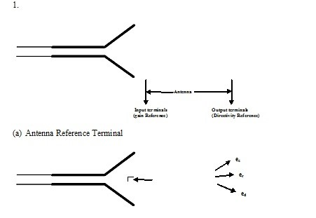

Figure 2.5: Reference Terminals And Losses Of An Antenna (b) Reflection, Conduction And Dielectric Losses

In general, the overall efficiency can be written as

*e*0 = *ecered* (2.5)

Where, *e*0 = *total efficiency* (*dimensionless*) *ec* = *conduction efficiency* (*dimensionless*) *er* = *reflection* (*mismatch efficiency*) (*dimensionless*) r = voltage reflection coefficient (mismatch efficiency) ( dimensionless )

*e*0 = *erecd* = *ecd*(1 − |*r*|2) (2.6)

*Where ecd* =antenna radiation efficiency, which is used to relate gain and directivity.

*2.8 Gain*

## 2.7.1 Standing Wave Ratio

Standing wave ratio (SWR) is defined as “the impedance mismatch between the input terminal and the output terminal”. In other words, it is the ratio of maximum forward wave to the minimum reflected wave. If there is no mismatch between transmission line and the input terminal, then ideally SWR is unity. SWR is very important parameter to operate an antenna properly. It is necessary that antenna must have VSWR less than 2 for an efficient performance.

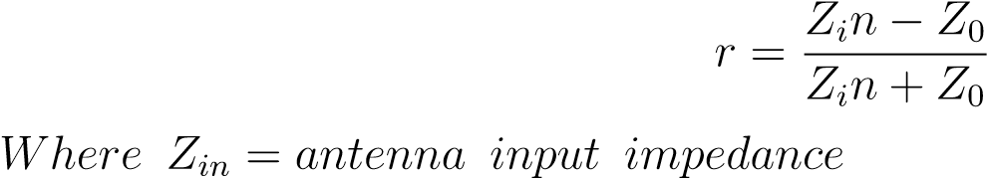 (2.7)

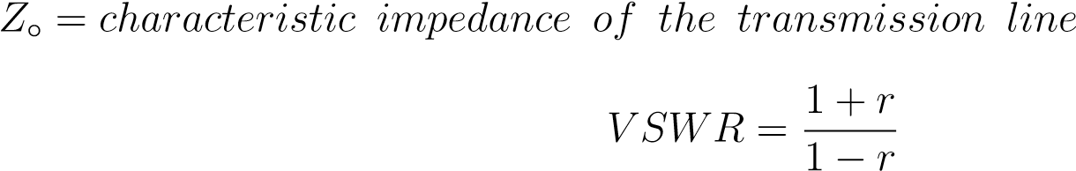 (2.8)

## 2.7.2 Return Loss

Return loss is another way to represent the mismatch between the antenna and the transmission line. It is defined as “logarithmic ratio measured in dB that compares the power reflected by the antenna to the power fed into the antenna from the transmission line”.

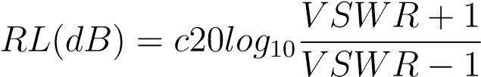 (2.9)

# 2.8 Gain

Gain of an antenna is closely related to the directivity, it is a measure that takes into account the efficiency of the antenna as well as its directional capabilities. Gain of antenna is classified in two ways, absolute gain and relative gain.

Absolute gain of an antenna in a given direction is defined as “the ratio of the intensity, in a given direction, to the radiation intensity that would be obtained if the power accepted by the antenna were radiated isotropically. The radiation intensity corresponding to the isotropically radiated power is equal to the power accepted (input) by the antenna divided by 4pi”. In the form of equation, it can be expressed as

) (2.10)

Relative gain is defined as “the ratio of the power gain in a given direction to the power gain of a reference antenna in its referenced direction”. The input power must be same for both antennas. The reference antenna can be any antenna whose gain can be calculated or it is known. In most cases, however, the reference antenna is a lossless isotropic source. Thus

) (2.11)

*2.11 Efficiency*

When the direction is not stated, the power gain is taken in the direction of maximum radiation.

The total power radiated (*Prad*) from the antenna is related to the total input power (*Pin*)

|  |  |
| --- | --- |
| delivered to the source. |  |
| *Prad* = *ecdPin* | (2.12) |

# 2.9 Efficiency

Consider a dish antenna pointed at an isotropic antenna transmitting some distance away. We know that the isotropic antenna radiates uniformly in all directions, so it is a simple matter of spherical geometry to calculate how much of that power should be arriving at the dish over its whole aperture. Now we measure how much power is being received from the dish (at the electrical connection to the feed) never greater than is arriving at the aperture. The ratio of power received to power arriving is the aperture efficiency.

How much efficiency should we expect? For dishes, all the books say that 55% is reasonable, and 70 to 80% is possible with very good feeds. Several ham articles have calculated gain based on 65% efficiency, but I haven’t found measured data to support any of these numbers. On the other hand, KI4VE 3 suggests that the amateur is lucky to achieve **45-50**% efficiency with a small dish and a typical “coffee-can” feed.

For horns and lenses, 50% efficiency is also cited as typical. Thus we should expect the same gain from any of these antennas if the aperture area is the same.

# 2.10 Reciprocity

If we transmit alternately with a smaller and a larger dish, is there any reason that the relative power received at a distant antenna would be any different than the relative power received by the two dishes? No, but a mathematical proof 4,5 is surprisingly difficult. Transmitting and receiving gains and antenna patterns are identical.

However, the relative noise received by different types of antennas may differ, even with identical antenna gains. Thus, the received signal-to-noise ratio may be better with one type of antenna compared to another.

# 2.11 Bandwidth

The bandwidth of an antenna is defined as “the range of frequencies over which the antenna can operate satisfactorily”. It depends upon the specification of antenna with respect to the frequency to meet the desire results in particular band. Broadband Antennas: expressed as the ratio of upper-to-lower frequencies of acceptable operation For example, 10:1 bandwidth

*2.13 Polarization*

indicates that the upper frequency is 10 times greater than the lower. For the narrow band antenna it can be calculated as

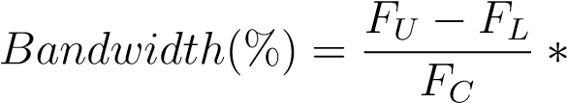100 (2.13)

For example, a 5% BW indicates that the frequency difference of acceptable operation is 5% of the centre frequency.

# 2.12 Polarization

Polarization of a radiated wave is defined as “that property of an electromagnetic wave describes the time-varying direction and relative magnitude of the electric field vector”. In the similar way, the polarization of an electromagnetic wave is defined as the orientation of the electric field vector or the polarization of a wave can be defined in terms of a wave radiated (transmitted or received) by an antenna in a given direction. Wave is frequently composed of (or can be broken down into) two orthogonal components as shown in fig 2.6

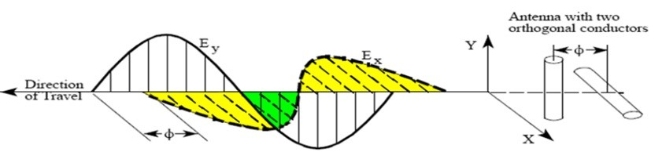

Figure 2.6: Electric And Magnetic Field Component

# 2.13 Types Of Antenna

Antennas can be classified in several ways. One way is the frequency band of operation. Others include physical structure and electrical/electromagnetic design. The antennas commonly used for LMRboth at base stations and mobile unitsrepresent only a very small portion of all the antenna types.

Most simple, nondirectional antennas are basic dipoles or monopoles. More complex, directional antennas consist of arrays of elements, such as dipoles, or use one active and several passive elements, as in the Yagi antenna.

New antenna technologies are being developed that allow an antenna to rapidly change its pattern in response to changes in direction of arrival of the received signal. These antennas and the supporting technology are called adaptive or “smart” antennas and may be used for the higherfrequency LMR bands in the future.

## 2.13.1 Corner Reflector

An antenna comprised of one or more dipole elements in front of a corner reflector, called the corner-reflector antenna. A photograph of a typical corner reflector is shown in figure

2.7. This antenna has moderately high gain, but its most important pattern feature is that

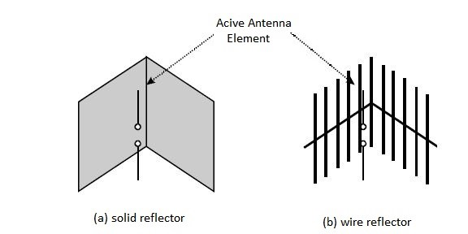

Figure 2.7: Corner Reflector antennas

the forward (main beam) gain is much higher than the gain in the opposite direction. This is called the front-to-back ratio.

## 2.13.2 Yagi

Another antenna design that uses passive elements is the Yagi antenna. This antenna, illustrated in figure 2.8, is inexpensive and effective. It can be constructed with one ormore (usually one or two) reflector elements and one or more (usually two or more) director elements.

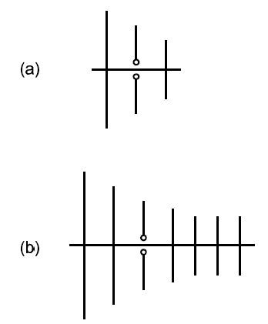

Figure 2.8: The Yagi antenna (a) three elements and (b) multiple elements

Figure 2.9 is a typical pattern for a three element (one reflector, one active element, and one director) Yagi antenna. Generally, the more elements a Yagi has, the higher the gain, and the narrower the beamwidth. This antenna can be mounted to support either horizontal or vertical polarization and is often used for point-to-point applications, as between a base station and repeater-station sites.

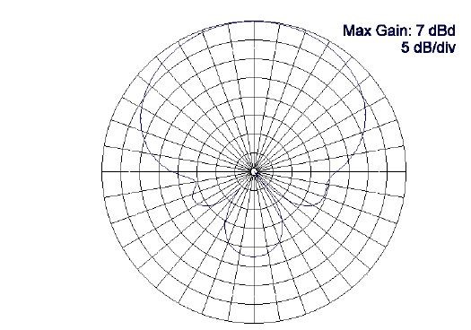

Figure 2.9: A Yagi antenna horizontalplane pattern

## 2.13.3 Arrays

An antenna array (or array antenna) is, much like it sounds, several elements interconnected and arranged in a regular structure to form an individual antenna. The purpose of an array is to produce radiation patterns that have certain desirable characteristics that a single element would not. A stacked dipole array, as shown in figure 2.10, is comprised of vertical dipole elements.

This dipole array has an omnidirectional pattern like the element dipole does; but has higher gain and a narrower main lobe beamwidth in the vertical plane. Figure 2.11 shows how the vertical-plane gain of the dipole element can be enhanced by making an array of them. Figure 2.11(a) represents the radiation pattern of one element. Figure 2.11(b) is the pattern of two elements, and figure 2.11(c) is for three elements.

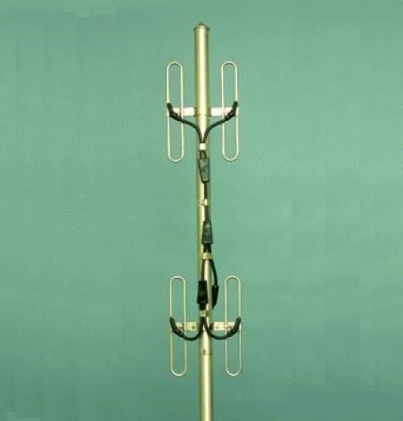

Figure 2.10: A typical vertical array using folded dipoles

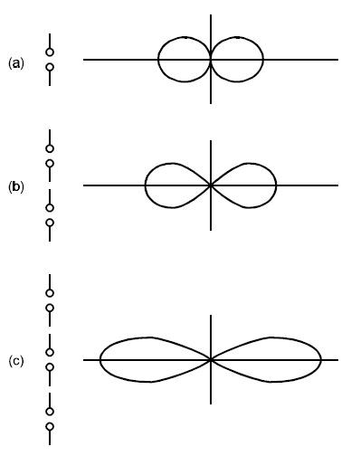

Figure 2.11: Vertical-plane radiation patterns for (a) single half-wave dipole, (b) twoelement array, and (c) three element array

## 2.13.4 Half Wave Dipole Antenna

The half wave dipole antenna becomes quite common where space permits. It can be erected vertically but is more often than not erected horizontally for practical reasons. I gave quite a good example of its use in my paper on radio telescopes from my original site. This

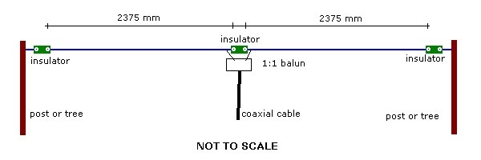

Figure 2.12: Half Wave Dipole Antenna

particular antenna was dimensioned for use at 30 Mhz. You will note that the left and right hand halves are merely quarter wave sections determined by the formula given earlier. The input impedance (affected by many factors) is nominally 50 ohms.

As with all antennas, the height above ground and proximity to other objects such as buildings, trees, guttering etc. play an important part. However, reality says we must live with what we can achieve in the real world notwithstanding what theory may say.

People erect half wave dipoles in attics constructed of fine gauge wire - far from ideal but they get reasonable results by living with less than the “ideal”. A lesson in life we should always remember in more ways than one.

## 2.13.5 The Folded Dipole Antenna

The folded dipole antenna is probably only ever seen as a TV antenna. It exhibits an impedance of 300 ohms whereas a half wave dipole is 75 ohms and I’m certain someone will be alert enough to ask “why 75 ohms, if figure 3 above is 50 ohms?”.

Within the limits of my artistic skills I have depicted a folded dipole antenna below.

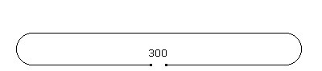

Figure 2.13: Half Wave Folded Dipole

## 2.13.6 Loop Antenna

A loop antenna is an antenna primarily for the AM broadcast and the Longwave bands. There are two different types of loop antennas, one is the ferrite bar (as in your am radio), the other is wound on an air core form. A loop antenna is very directional. The pickup pattern is shaped like a figure eight. The loop will allow signals on opposite sides to be received, while off the sides of the loop the signal will decrease or be nulled out. The nulling feature will allow you to remove a local station on a frequency and pick up another on the same frequency by removing the local signal. A loop may have an amplifier or may not. Air core loop antennas come in many sizes. The larger the loop the more gain there is. A small loop will actually lose part of the signal. That is why most small loops will use an amplifier. There are two ways a loop can be wound, box or spiral. In the box or solenoid loop the plane of the winding are wound perpendicular to the diameter of the loop, so each loop is the same size. In the spiral loop the plane of the windings are wound parallel with the diameter of the loop, so each loop gets smaller as you wind into the center of the loop. A loop needs to be able to rotate to null out a station. And a loop also needs to be able to till from vertical. This also helps in in nulling of a signal (altazimuth feature).

The number of turns the loop needs is determined by the size of the loop, the frequency range that you want to tune and the value of your tuning capacitor. The larger the loop the fewer turns you will need. A 4 foot loop needs 8 turns and a 2 foot loop needs 18 turns. The capacitor that is used is the standard AM tuning capacitor with a range of 10 to 365 pf. The tuning capacitor is used to tune the loop to the frequency that you want to listen

*2.14 Horn*

to. When you are tuned in to the frequency the signal will peak. You may not be able to tune the full frequency range that you want to tune. So you will need to use a 2 section capacitor and switch the second section in. (more capacitance)

### Advantages Of Loop Antenna

a). No available space for a longwire antenna

b). To eliminate unwanted signals, and noise

c). Radio Direction Finding

d). To improve the performance of a simple receiving system, by providing pre-selection which improves image rejection, and adjacent channel selectivity.

# 2.14 Horn Antenna

A horn antenna or microwave horn is an antenna that consists of a flaring metal waveguide shaped like a horn to direct the radio waves. Horns are widely used as antennas at UHF and microwave frequencies, above 300 MHz They are used as feeders (called feed horns) for larger antenna structures such as parabolic antennas, as standard calibration antennas to measure the gain of other antennas, and as directive antennas for such devices as radar guns, automatic door openers, and microwave radiometers. Their advantages are moderate directivity (gain), low SWR, broad bandwidth, and simple construction and adjustment.

One of the first horn antennas was constructed in 1897 by Indian radio researcher Jagadish Chandra Bose in his pioneering experiments with microwaves. In the 1930s the first experimental research (South worth and Barrow, 1936) and theoretical analysis ( Barrow and Chu, 1939) of horns as antennas was done. The development of radar in World War 2 stimulated horn research. The corrugated horn proposed by Kay in 1962 has become widely used as a feed horn for microwave antennas such as satellite dishes and radio telescopes. An advantage of horn antennas is that since they don’t have any resonant elements, they can operate over a wide range of frequencies, a wide bandwidth. The useable bandwidth of horn antennas is typically of the order of 10:1, and can be up to 20:1 (for example allowing it to operate from 1 GHz to 20 GHz). The input impedance is slowly-varying over this wide frequency range, allowing low VSWR over the bandwidth. The gain of horn antennas ranges up to 25 dBi, with 10 - 20 dBi being typical.

## 2.14.1 Types Of Horn Antennas

These are the common types of horn antenna. Horns can have different flare angles as well as different expansion curves (elliptic, hyperbolic, etc.) in the E-field and H-field directions, making possible a wide variety of different beam profiles.

1. Pyramidal horn - a horn antenna with the horn in the shape of a four-sided pyramid, with a rectangular cross section. They are the most widely used type, used with rectangular waveguides, and radiate linearly polarized radio waves.
2. Sectoral horn - A pyramidal horn with only one pair of sides flared and the other pair parallel. It produces a fan-shaped beam, which is narrow in the plane of the flared sides,

*2.14 Horn*

but wide in the plane of the narrow sides.

1. E-plane horn - A sectoral horn flared in the direction of the electric or E-field in the waveguide.
2. H-plane horn - A sectoral horn flared in the direction of the magnetic or H-field in the waveguide.
3. Conical horn - A horn in the shape of a cone, with a circular cross section. They are used with cylindrical waveguides.
4. Corrugated horn - A horn with parallel slots or grooves, small compared with a wavelength, covering the inside surface of the horn, transverse to the axis. Corrugated horns have wider bandwidth and smaller side lobes and cross-polarization, and are widely used as feed horns for satellite dishes and radio telescopes.
5. Ridged horn - A pyramidal horn with ridges or fins attached to the inside of the horn, extending down the center of the sides. The fins lower the cutoff frequency, increasing the antenna’s bandwidth.
6. Septum horn - A horn which is divided into several sub horns by metal partitions (septum) inside, attached to opposite walls.
7. Aperture-limited horn - a long narrow horn, long enough so the phase error is a fraction of a wavelength,so it essentially radiates a plane wave. It has an aperture efficiency of 1.0 so it gives the maximum gain and minimum beam width for a given aperture size. The gain is not affected by the length but only limited by diffraction at the aperture.

**Chapter 3**

**STEPPING MOTORS AND TYPES**

# 3.1 Introduction

Stepping motors come in two varieties, permanent magnet and variable reluctance (there are also hybrid motors, which are indistinguishable from permanent magnet motors from the controller’s point of view). Lacking a label on the motor, you can generally tell the two apart by feel when no power is applied. Permanent magnet motors tend to “cog” as you twist the rotor with your fingers, while variable reluctance motors almost spin freely (although they may cog slightly because of residual magnetization in the rotor). You can also distinguish between the two varieties with an ohmmeter. Variable reluctance motors usually have three (sometimes four) windings, with a common return, while permanent magnet motors usually have two independent windings, with or without center taps. Center-tapped windings are used in unipolar permanent magnet motors.

Stepping motors come in a wide range of angular resolution. The coarsest motors typically turn 90 degrees per step, while high resolution permanent magnet motors are commonly able to handle 1.8 or even 0.72 degrees per step. With an appropriate controller, most permanent magnet and hybrid motors can be run in half-steps, and some controllers can handle smaller fractional steps or microsteps. For both permanent magnet and variable reluctance stepping motors, if just one winding of the motor is energised, the rotor ( under no load) will snap to a fixed angle and then hold that angle until the torque exceeds the holding torque of the motor, at which point, the rotor will turn, trying to hold at each successive equilibrium point.

# 3.2 Variable Reluctance Motors

If your motor has three windings, typically connected as shown in the schem- atic diagram in Figure 1.1, with one terminal common to all windings, it is most likely a variable reluctance stepping motor. In use, the common wire typically goes to the positive supply and the windings are energized in sequence. The cross section shown in Figure 1.1 is of 30 degree per step variable reluctance motor. The rotor in this motor has 4 teeth and the stator has 6 poles, with each winding wrapped around two opposite poles. With winding number 1

20

*3.3 Unipolar*

energised, the rotor teeth marked X are attracted to this winding’s poles. If the current through winding 1 is turned off and winding 2 is turned on, the rotor will rotate 30 degrees clockwise so that the poles marked Y line up with the poles marked 2[6, 8].

To rotate this motor continuously, we just apply power to the 3 windings in sequence. Assuming positive logic, where a 1 means turning on the current through a motor winding, the following control sequence will spin the motor illustrated in Figure clockwise 24 steps or 2 revolutions:

Winding 1 1001001001001001001001001

Winding 2 0100100100100100100100100

Winding 3 0010010010010010010010010

The section of this tutorial on Mid-Level Control provides details on methods for generating such sequences of control signals, while the section on Control Circuits discusses the power switching circuitry needed to drive the motor windings from such control sequences. There are also variable reluctance stepping motors with 4 and 5 windings, requiring 5 or 6 wires. The principle for driving these motors is the same as that for the three winding variety, but it becomes important to work out the correct order to energise the windings to make the motor step nicely. The motor geometry illustrated in Figure 1.1, giving 30 degrees per step, uses the fewest number of rotor teeth and stator poles that performs satisfactorily. Using more motor poles and more rotor teeth allows construction of motors with smaller step angle. Toothed faces on each pole and a correspondingly finely toothed rotor allows for step angles as small as a few degrees.

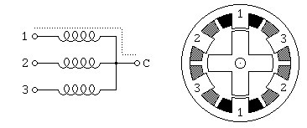

Figure 3.1: Variable Reluctance Motor

# 3.3 Unipolar Motors

Unipolar stepping motors, both Permanent magnet and hybrid stepping motors with 5 or 6 wires are usually wired as shown in the schematic in Figure 1.2, with a center tap on each of two windings. In use, the center taps of the windings are typically wired to the positive supply, and the two ends of each winding are alternately grounded to reverse the direction of the field provided by that winding. The motor cross section shown in Figure 1.2 is of a 30 degree per step permanent magnet or hybrid motor – the difference between these two motor types is not relevant at this level of abstraction. Motor winding number 1 is distributed between the top and bottom stator pole, while motor winding number 2 is

*3.4 Unipolar*

distributed between the left and right motor poles. The rotor is a permanent magnet with 6 poles, 3 souths’ and 3 norths’, arranged around its circumference.

For higher angular resolutions, the rotor must have proportionally more poles. The 30 degree per step motor in the figure is one of the most common permanent magnet motor designs, although 15 and 7.5 degree per step motors are widely available. Permanent magnet motors with resolutions as good as 1.8 degrees per step are made, and hybrid motors are routinely built with 3.6 and 1.8 degrees per step, with resolutions as fine as 0.72 degrees per step available.

As shown in the figure, the current flowing from the center tap of winding 1 to terminal a causes the top stator pole to be a north pole whiles the bottom stator pole is a south pole. This attracts the rotor into the position shown. If the power to winding 1 is removed and winding 2 is energized, the rotor will turn 30 degrees, or one step.

To rotate the motor continuously, we just apply power to the two windings in sequence. Assuming positive logic, where a 1 means turning on the current through a motor winding, the following two control sequences will spin the motor illustrated in Figure 1.2 clockwise 24 steps or 2 revolutions:

|  |  |  |
| --- | --- | --- |
| Winding | 1a | 1000100010001000100010001 |
| Winding | 1b | 0010001000100010001000100 |
| Winding | 2a | 0100010001000100010001000 |
| Winding | 2b | 0001000100010001000100010 |
| Winding | 1a | 1100110011001100110011001 |
| Winding | 1b | 0011001100110011001100110 |
| Winding | 2a | 0110011001100110011001100 |
| Winding | 2b | 1001100110011001100110011 |

Note that the two halves of each winding are never energized at the same time. Both sequences shown above will rotate a permanent magnet one step at a time. The top sequence only powers one winding at a time, as illustrated in the figure above; thus, it uses less power. The bottom sequence involves powering two windings at a time and generally produces a torque about 1.4 times greater than the top sequence while using twice as much power.

The section of this tutorial on Mid-Level-Control provides details on methods for generating such sequences of control signals, while the section on Control Circuit discusses the power switching circuitry needed to drive the motor windings from such control sequences. The step positions produced by the two sequences above are not the same; as a result, combining the two sequences allows half stepping, with the motor stopping alternately at the positions indicated by one or the other sequence. The combined sequence is as follows:

|  |  |  |
| --- | --- | --- |
| Winding | 1a | 11000001110000011100000111 |
| Winding | 1b | 00011100000111000001110000 |
| Winding | 2a | 01110000011100000111000001 |
| Winding | 2b | 00000111000001110000011100 |

*3.4 Bipolar*

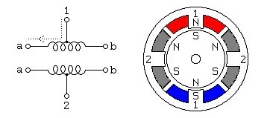

Figure 3.2: Unipolar Motor

# 3.4 Bipolar Motors

Bipolar permanent magnet and hybrid motors are constructed with exactly the same mechanism as is used on unipolar motors, but the two windings are wired more simply, with no center taps. Thus, the motor itself is simpler but the drive circuitry needed to reverse the polarity of each pair of motor poles is more complex. The schematic in Figure 3.3 shows how such a motor is wired, while the motor cross section shown here is exactly the same as the cross section shown in Figure 3.2.

The drive circuitry for such a motor requires an H-bridge control circuit for each winding; these are discussed in more detail in the section on Control Circuit. Briefly, an H-bridge allows the polarity of the power applied to each end of each winding to be controlled independently. The control sequences for single stepping such a motor are shown below, using + and - symbols to indicate the polarity of the power applied to each motor terminal:

|  |  |  |
| --- | --- | --- |
| Terminal | 1a | + - - - + - - - + - - - + - - - + + - - + + - - + + - - + + - - |
| Terminal | 1b | - - + - - - + - - - + - - - + - - - + + - - + + - - + + - - + + |
| Terminal | 2a | - + - - - + - - -+ – - + - - - + + - -+ +- - + + - - + + - |
| Terminal | 2b | - - - + - - -+ - - -+ - - - + + - - + + - - + + - - + + - - + Note |

that these sequences are identical to those for a unipolar permanent magnet motor, at an abstract level, and that above the level of the H-bridge power switching electronics, the control systems for the two types of motor can be identical.

Enable 1 1010101010101010 1111111111111111

Direction 1 1x0x1x0x1x0x1x0x 1100110011001100

Enable 2 0101010101010101 1111111111111111

Direction 2 x1x0x1x0x1x0x1x0 0110011001100110

To distinguish a bipolar permanent magnet motor from other 4 wire motors, measure the resistances between the different terminals. It is worth noting that some permanent magnet stepping motors have 4 independent windings, organized as two sets of two. Within each set, if the two windings are wired in series, the result can be used as a high voltage bipolar motor. If they are wired in parallel, the result can be used as a low voltage bipolar motor.

*3.5 Bifilar*

If they are wired in series with a center tap, the result can be used as a low voltage unipolar motor.

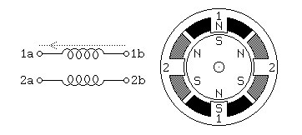

Figure 3.3: Bipolar Motor

# 3.5 Bifilar Motors

Bifilar windings on a stepping motor are applied to the same rotor and stator geometry as a bipolar motor, but instead of winding each coil in the stator with a single wire, two wires are wound in parallel with each other. As a result, the motor has 8 wires, not four. In practice, motors with bifilar windings are always powered as either unipolar or bipolar motors.Figure 3.4 shows the alternative connections to the windings of such a motor. To use a bifilar motor as a unipolar motor, the two wires of each winding are connected in series and the point of connection is used as a center-tap. Winding 1 in Figure 3.4 is shown connected this way.To use a bifilar motor as a bipolar motor, the two wires of each winding are connected either in parallel or in series. Winding 2 in Figure 3.4 is shown with a parallel connection; this allows low voltage high-current operation. Winding 1 in Figure 3.4 is shown with a series connection; if the center tap is ignored, this allows operation at a higher voltage and lower current than would be used with the windings in parallel. It should be noted that essentially all 6-wire motors sold for bipolar use are actually wound using bifilar windings, so that the external connection that serves as a center tap is actually connected as shown for winding 1 in Figure 3.4. Naturally, therefore, any unipolar motor may be used as a bipolar motor at twice the rated voltage and half the rated current as is given on the nameplate.

The question of the correct operating voltage for a bipolar motor run as a unipolar motor, or for a bifilar motor with the motor windings in series is not as trivial as it might first appear. There are three issues: The current carrying capacity of the wire, cooling the motor, and avoiding driving the motor’s magnetic circuits into saturation. Thermal considerations suggest that, if the windings are wired in series, the voltage should only be raised by the square root of 2. The magnetic field in the motor depends on the number of ampere turns; when the two half-windings are run in series, the number of turns is doubled, but because a well-designed motor has magnetic circuits that are close to saturation when the motor is run at its rated voltage and current, increasing the number of ampere-turns does not make the field any stronger. Therefore, when a motor is run with the two half-windings in series,

*3.6 Multiphase*

the current should be halved in order to avoid saturation; or, in other words, the voltage across the motor winding should be the same as it was.

For those who salvage old motors, finding an 8-wire motor poses a challenge! Which of the 8 wires is which? It is not hard to figure this out using an ohm meter, an AC volt meter, and a low voltage AC source. First, use the ohm meter to identify the motor leads that are connected to each other through the motor windings. Then, connect a low-voltage AC source to one of these windings. The AC voltage should be below the advertised operating voltage of the motor; voltages under 1 volt are recommended. The geometry of the magnetic circuits of the motor guarantees that the two wires of a bifilar winding will be strongly coupled for AC signals, while there should be almost no coupling to the other two wires. Therefore, probing with an AC volt meter should disclose which of the other three windings is paired to the winding under power[13].

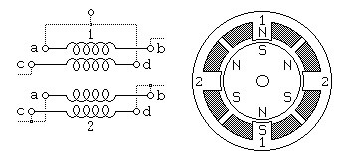

Figure 3.4: Bifilar Motor

# 3.6 Multiphase Motors

A less common class of permanent magnet or hybrid stepping motor is wired with all windings of the motor in a cyclic series, with one tap between each pair of windings in the cycle, or with only one end of each motor winding exposed while the other ends of each winding are tied together to an inaccessible internal connection. In the context of 3- phase motors, these configurations would be described as Delta and Y configurations, but they are also used with 5-phase motors, as illustrated in Figure 1.5. Some multiphase motors expose all ends of all motor windings, leaving it to the user to decide between the Delta and Y configurations, or alternatively, allowing each winding to be driven independently. Control of either one of these multiphase motors in either the Delta or Y configuration requires 1/2 of an H-bridge for each motor terminal. It is noteworthy that 5-phase motors have the potential of delivering more torque from a given package size because all or all but one of the motor windings are energized at every point in the drive cycle. Some 5phase motors have high resolutions on the order of 0.72 degrees per step (500 steps per revolution. Many automotive alternators are built using 3-phase hybrid geometry with either a permanent magnet rotor or an electromagnet rotor powered through a pair of sliprings. These have been successfully used as stepping motors in some heavy duty industrial

*3.6 Multiphase*

applications; step angles of 10 degrees per step have been reported.

With a 5-phase motor, there are 10 steps per repeat in the stepping cycle, as shown below:

|  |  |  |
| --- | --- | --- |
| Terminal | 1 | + + + - - - - -+ + + + + - - - - - + + |
| Terminal | 2 | - - + + + ++ - - - - - + + + + + - - - |
| Terminal | 3 | + - - - - - + + + ++ - - - - - + + + + |
| Terminal | 4 | + + + + + - - - – + + + + + - - - - - |
| Terminal | 5 | - - - - + + + + + - - - - - + + + + + - |

With a 3-phase motor, there are 6 steps per repeat in the stepping cycle, as shown below:

Terminal 1 + + + - - - + + + - - -

Terminal 2 - - + + + - - - + + + -

Terminal 3 + - - - + + + - - - + +

Here, as in the bipolar case, each terminal is shown as being either connected to the positive or negative bus of the motor power system. Note that, at each step, only one terminal changes polarity. This change removes the power from one winding attached to that terminal (because both terminals of the winding in question are of the same polarity) and applies power to one winding that was previously idle. Given the motor geometry suggested by Figure 1.5, this control sequence will drive the motor through two revolutions.

To distinguish a 5-phase motor from other motors with 5 leads, note that, if the resistance between two consecutive terminals of the 5-phase motor is R, the resistance between nonconsecutive terminals will be 1.5R[14].

Note that some 5-phase motors have 5 separate motor windings, with a total of 10 leads. These can be connected in the star configuration shown below, using 5 half-bridge driver circuits, or each winding can be driven by its own full-bridge. While the theoretical component count of half-bridge drivers is lower, the availability of integrated full-bridge chips may make the latter approach preferable.

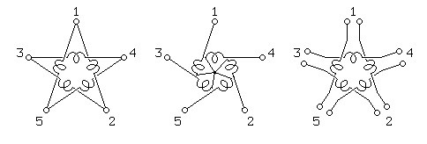

Figure 3.5: Multiphase Motor

**Chapter 4**

**STEPPER MOTOR AND OPERATION**

After the basic theory and introduction we will explain the operation of stepper motor as we have mentioned in the early chapter, it operate on digital pulses. These pulses are applied a specific way. There are two possible ways to control the stepper motor which are given here in detail.

### i. half step interleaving ii. full step interleaving

# 4.1 Other Stepper Motors

1. A stepper motor with 5 wires is almost certainly 4-phase unipolar.
2. A stepper motor with 6 wires is probably also 4-phase unipolar, but with two Common Power wires. They may both be the same colour. iii. A stepper motor with only 4 wires is most likely bipolar. Information on that type is available elsewhere
3. **Isolate the Common Power wires** by using an ohmmeter to check the resistances between pairs of wires. The Common Power wire will be the one with only half as much resistance between it and all the others.

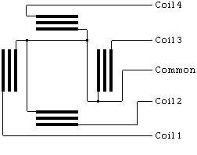

This is because the Common Power wire only has one coil between it and each other wire,

27

whereas each of the other wires have two coils between them. Hence half the resistance.

1. **Identify the wires to the coils** by supplying a voltage on the Common Power wires and keeping one of the other wires grounded while grounding each of the remaining three wires in turn and observing the results.

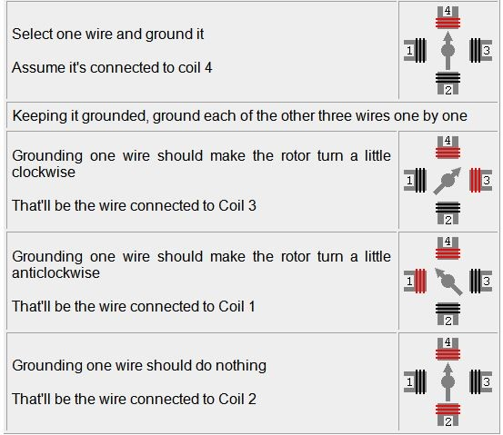

# 4.2 Interleaving One Wire

To control stepper motor we use one bit at a time i.e. we activate one wire of the stepper motor that generate a magnetic field and causes the motor to move in a specific direction depending on the sequence in which we activate the wires of the motor.

## 4.2.1 Counter Clockwise Motion

If we consider four wires stepper motor and we want to rotate the stepper in counter clockwise direction by activating one wire at a time we will apply the following sequence.

|  |  |  |  |  |
| --- | --- | --- | --- | --- |
| **Bit sequence** | **wire1** | **wire2** | **wire3** | **wire4** |
|  | **1** | **0** | **0** | **0** |
|  | **0** | **1** | **0** | **0** |
|  | **0** | **0** | **1** | **0** |
|  | **0** | **0** | **0** | **1** |

The whole operation is shown here.

1. activating 1*st* wire

**Interleaved Single Wire**

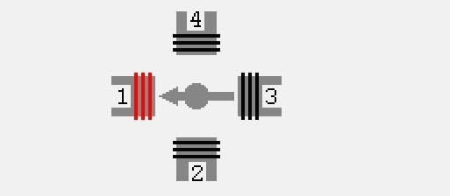

BIT SEQUENCE 1 0 0 0

1. activating 2*st* wire

**Interleaved Single Wire**

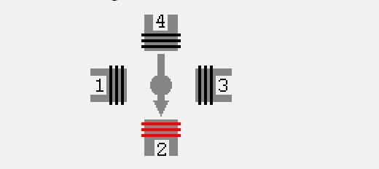

BIT SEQUENCE 0 1 0 0

1. activating 3*st* wire

**Interleaved Single Wire**

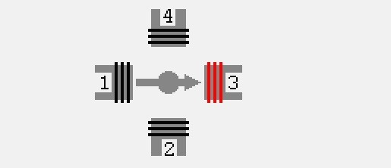

BIT SEQUENCE 0 0 1 0

1. activating 4*st* wire

**Interleaved Single Wire**

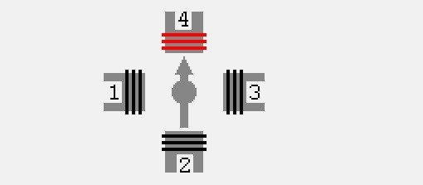

BIT SEQUENCE 0 0 0 1

This sequence is repeated over and over as we want to rotate the stepper motor. To complete full 360 degrees rotation of stepper motor the sequence repeated by a number depending on the total number of steps of the motor we use.

### The Matlab code for rotating stepper motor counter clockwise using full step interleaving is given here. Here one wire is activated at a time.

PsC=figure(0Name0,0Automatic Adjustable Antenna0,0NumberTitle0,0off0,... 0Units0,0normalized0,...

0Resize0,0off0,...

0Visible

0Color0,[.4 .5 .9],... 0Toolbar0,0none0,...

0Tag0,0extacy

0WindowStyle , normal0) ;

p=[0; 0; 0; 0; 0; 0; 0; 0; 0; 0] ; q=[0; 0; 1; 1; 1; 1; 1; 1; 0; 0] ; bar=p; bar=horzcat(bar,p); for w=1:199 bar=horzcat(bar,q); end bar=horzcat(bar,p); bar=horzcat(bar,p); extacy = imshow(bar);

steps=[ 1 0 0 0 ; 0 1 0 0 ; 0 0 1 0 ; 0 0 0 1] ; i=1; k=1;

parport=digitalio( 0parallel’, 0LPT1’); line=addline(parport,0:3, 0out’); extacy = imshow(bar);

if j 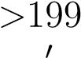title( Stoped: Programme Ends’, 0FontWeight’, 0bold’); else

title( 0Snigle Rotation in Counter Clockwise Direction’, 0FontWeight’, 0bold’); end bar(:,j+2)=p; pval=steps(i,:); i=i+1; putvalue(parport,pval); gval = getvalue(parport);

*if j >* 199

i=1; end

tic;

while(toc*< .*2) ; pause(0.1); end;

pval = [0 0 0 0 ] ;

gval = getvalue(parport); delete parport; clear parport;

# 4.3 Clockwise Motion.

Now for rotating the stepper motor in clockwise direction activating one wire at a time using a One Bit, we will simply change the sequence we applied in the previous case. The new sequence will be

|  |  |  |  |  |
| --- | --- | --- | --- | --- |
| **Bit sequence** | **wire1** | **wire2** | **wire3** | **wire4** |
|  | **1** | **0** | **0** | **0** |
|  | **0** | **0** | **0** | **1** |
|  | **0** | **0** | **1** | **0** |
|  | **0** | **1** | **0** | **0** |

a) activating 1*st* wire

### Interleaved Single Wire



BIT SEQUENCE 1 0 0 0

b) activating 4*st* wire

### Interleaved Single Wire



BIT SEQUENCE 0 0 0 1

c) activating 3*st* wire

### Interleaved Single Wire



BIT SEQUENCE 0 0 1 0

d) activating 2*st* wire

### Interleaved Single Wire



BIT SEQUENCE 0 1 0 0

### The Matlab code for rotating stepper motor clockwise using full step interleaving is given here. Here one wire is activated at a time.

PsC=figure(0Name0,0Automatic Adjustable Antenna0,0NumberTitle0,0off0,... 0Units0,0normalized0,...

0Resize0,0off0,...

0Visible

0Color0,[.4 .5 .9],... 0Toolbar0,0none0,...

0Tag0,0extacy0,...

0WindowStyle0,0normal0) ;

p=[0; 0; 0; 0; 0; 0; 0; 0; 0; 0] ; q=[0; 0; 1; 1; 1; 1; 1; 1; 0; 0] ; bar=p; bar=horzcat(bar,p); for w=1:199 bar=horzcat(bar,q); end bar=horzcat(bar,p); bar=horzcat(bar,p); extacy = imshow(bar);

steps=[ 0 0 0 1 ; 0 0 1 0 ; 0 1 0 0 ; 1 0 0 0] ; i=1; k=1; parport=digitalio( 0parallel’, 0LPT1’); line=addline(parport,0:3, 0out’); extacy = imshow(bar); *if j >* 199

title( 0Stoped: Programme Ends’, 0FontWeight’, 0bold’); else title( 0Snigle Rotation in Clockwise Direction’, 0FontWeight’, 0bold’); end bar(:,j+2)=p; pval=steps(i,:); i=i+1; putvalue(parport,pval); gval = getvalue(parport);

*if j >* 199

i=1; end

tic;

while(toc*< .*2) ; pause(0.1); end;

pval = [0 0 0 0 ] ;

gval = getvalue(parport); delete parport; clear parport;

# 4.4 Interleaving Two Wires

Interleaving two wires at a time can also be used to achieve full step interleaving. This can done to excite two adjacent wires at time and the rotation is controlled by using a specific bit sequence.The direction of rotation depends on the sequence which is followed for the stepper motor.

## 4.4.1 Counter Clockwise Motion

If we consider four wires stepper motor and we want to rotate the stepper in counter clockwise direction by activating two wires at a time we will apply the following sequence

|  |  |  |  |  |
| --- | --- | --- | --- | --- |
| **Bit sequence** | **wire1** | **wire2** | **wire3** | **wire4** |
|  | **1** | **1** | **0** | **0** |
|  | **0** | **1** | **1** | **0** |
|  | **0** | **0** | **1** | **1** |
|  | **1** | **0** | **0** | **1** |

This sequence is repeated over and over as we want to rotate the stepper motor. To complete full 360 degrees rotation of stepper motor the sequence repeated by a number depending on the total number of steps of the motor we use.

The whole operation is shown here. a) activating 1*st* and 2*st* wire

**Interleaved Single Wire**

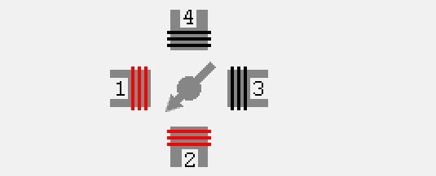

BIT SEQUENCE 1 1 0 0

|  |  |  |
| --- | --- | --- |
| b) activating 2*st* and 3*st* wire |  |  |
| **Interleaved** | **Single** | **Wire** |

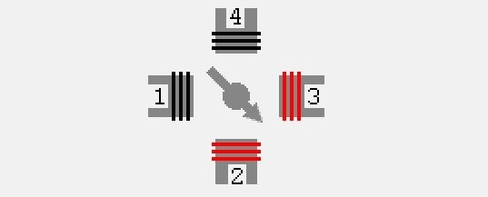

|  |  |  |
| --- | --- | --- |
| BIT SEQUENCE  c) activating 3*st* and 4*st* wire | 0 | 1 1 0 |
| **Interleaved** | **Single** | **Wire** |

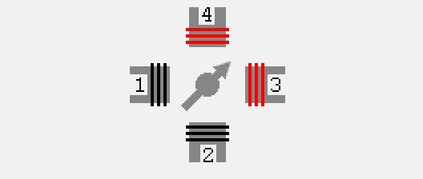

|  |  |  |  |  |
| --- | --- | --- | --- | --- |
| BIT SEQUENCE  d) activating 4*st*and 1*st* wire | 0 | 0 | 1 | 1 |

**Interleaved Single Wire**

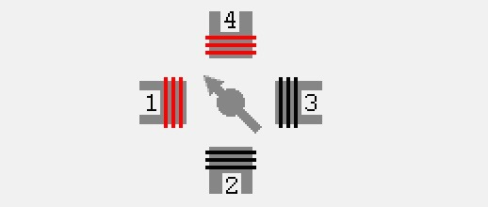

BIT SEQUENCE 1 0 0 1

### The Matlab code for rotating stepper motor counter clockwise using full step interleaving is given here. Note that two wires should be interleaved at a time.

PsC=figure([1]Name[2],0Automatic Adjustable Antenna0,NumberTitle0,0off0,... 0Units0,0normalized0,...

0Color0,[.4 .5 .9], ... 0Toolbar0, 0none0,...

0Tag0,0extacy0,...

0WindowStyle0, 0normal0) ; p=[0; 0; 0; 0; 0; 0; 0; 0; 0; 0] ; q=[0; 0; 1; 1; 1; 1; 1; 1; 0; 0] ; bar=p; bar=horzcat(bar,p); for w=1:199 bar=horzcat(bar,q); end bar=horzcat(bar,p); bar=horzcat(bar,p); extacy = imshow(bar); steps=[ 1 1 0 0 ; 0 1 1 0 ; 0 0 1 1 ;1 0 0 1] ;

i=1; k=1;

parport=digitalio(0parallel0,0LPT10) ; line=addline(parport,0:3,0out0) ; extacy = imshow(bar); if j*>*199 title(0Stoped: Programme Ends0,0FontWeight0,0bold’); else title(0Snigle Rotation in Counter Clockwise Direction0,0FontWeight0,0bold0) ; end bar(:,j+2)=p; pval=steps(i,:); i=i+1; putvalue(parport,pval); gval = getvalue(parport); if j*>*199 i=1; while(toc*<*.2) ; pause(0.1); end;

pval = [0 0 0 0 ] ;

putvalue(parport,pval); gval = getvalue(parport); delete(parport); clear parport;

## 4.4.2 Clockwise Motion

Now for rotating the stepper motor in clockwise direction activating one wire at a time using a One Bit, we will simply change the sequence we applied in the previous case. The new sequence will be

|  |  |  |  |
| --- | --- | --- | --- |
| **Bit sequence wire1** | **wire2** | **wire3** | **wire4** |
| **1** | **0** | **0** | **1** |
| **0** | **0** | **1** | **1** |
| **0** | **1** | **1** | **0** |
| **1**  a) activating 1*st* and 4*st* wire | **1** | **0** | **1** |
| **Interleaved** | | **Single** | **Wire** |



BIT SEQUENCE 1 0 0 1

b) activating 4*st* and 3*st* wire

**Interleaved Single Wire**



BIT SEQUENCE 0 0 1 1

|  |  |  |
| --- | --- | --- |
| c) activating 2*st* and 3*st* wire |  |  |
| **Interleaved** | **Single** | **Wire** |



|  |  |  |  |  |
| --- | --- | --- | --- | --- |
| BIT SEQUENCE  d) activating 1*st* and 2*st* wire | 0 | 1 | 1 | 0 |

**Interleaved Single Wire**



BIT SEQUENCE 1 1 0 0

### The Matlab code for rotating stepper motor clockwise using full step interleaving is given here. Note that two wires should be interleaved at a time.

PsC=figure([3]Name[4],[5]Automatic Adjustable Antenna[6],NumberTitle[7],0off0,... 0Units0,0normalized0,...

bar=horzcat(bar,p); bar=horzcat(bar,p); extacy = imshow(bar); steps=[ 1 1 0 0 ; 0 0 1 1; 0 1 1 0 ;1 1 0 0] ;

i=1; k=1;

parport=digitalio(0parallel0,0LPT10) ; line=addline(parport,0:3,0out0) ; extacy = imshow(bar); if j*>*199 title(0Stoped: Programme Ends0,0FontWeight0,0bold’); else title(0Snigle Rotation in Counter Clockwise Direction0,0FontWeight0,0bold0) ; end bar(:,j+2)=p; pval=steps(i,:); i=i+1; putvalue(parport,pval); gval = getvalue(parport); if j*>*199 i=1; while(toc*<*.2) ; pause(0.1); end;

pval = [0 0 0 0 ] ;

putvalue(parport,pval); gval = getvalue(parport); delete(parport); clear parport;

**Chapter 5**

**MATLAB AND INTERFACES**

# 5.1 Introduction

As we studied in the previous chapters that we have can control the stepping motor by interleaving one or two wires of the stepper motor by inputting a specific digital bit pattern.So we can provide this sequence through many ways but most appropriate in my view is to provide this through computer, which we have used in our project. A parallel port of computer is used to provide this.

# 5.2 The Parallel Port

The PC supports up to three parallel ports that are assigned the labels LPT1, LPT2, and LPT3. You can use any of these standard ports as long as they use the usual base addresses, which are (in hex) 378, 278, and 3BC, respectively. The port labels and addresses are typically configured through the PC’s BIOS. Additional ports, or standard ports not assigned the usual base addresses, are not accessible by the toolbox. Most PCs that support MATLAB will include a single parallel port with label LPT1 and base address 378.

# 5.3 Parallel Connector Pin Out

The parallel port socket on your computer uses 25 pins. On most peripherals like printers, the 36 pins Centronics version is used. Both connector pin outs are shown here. The centronics socket is named after the company that introduced the first dot matrix printer in 1970, but after IBM and Epson took over the dot matrix printer market (later followed by Hewlett Packard in the laser and DeskJet printer segment) most people only associates the word centronics with the port interface itself, not with a manufacturer.

40

*5.5 Parallel Printer Cable*

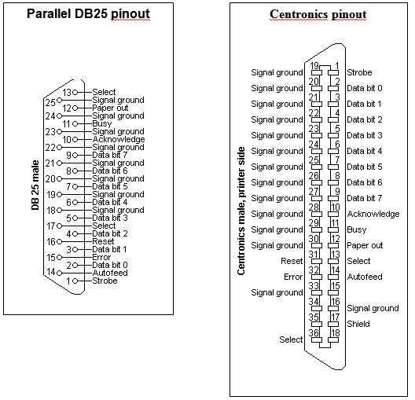

Figure 5.1: Centronics Pin Out

# 5.4 Parallel Printer Cable

Most printers are connected to a computer using a cable with a 25 pins DB male connector at one side and a 36 pins centronics connector on the other. The normal way to make such a cable is shown here.

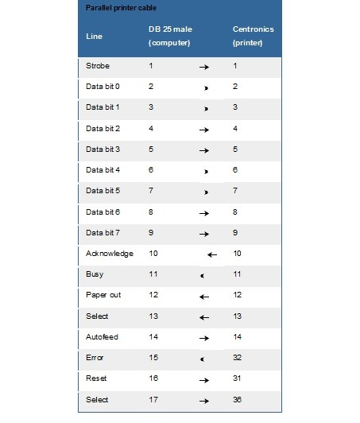

*5.6 Parallel Port Test Plugs*

# 5.5 Parallel Port Test Plugs

Both Norton Diagnostics and Check It have the ability to check the functionality of a parallel port. To do this, both software packages need a special plug on the port. Unfortunatel y, the pin layout of both connectors is not the same. The scheme of both sockets is given here .

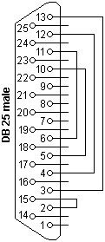

Figure 5.2: Norton Test Plug

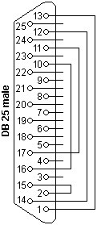

Figure 5.3: Check It Test Plug

# 5.6 The Parallel Port And Matlab.

The PC supports up to three parallel ports that are assigned the labels LPT1, LPT2, and LPT3. You can use any of these standard ports as long as they use the usual base addresses, which are (in hex) 378, 278, and 3BC, respectively. The port labels and addresses are typically configured through the PC’s BIOS. Additional ports, or standard ports not assigned the usual base addresses, are not accessible by the toolbox. Most PCs that support MATLAB will include a single parallel port with label LPT1 and base address 378. To create

a DIO object for this port,

Parport = digitalio ( ‘parallel’,‘LPT1’);

Adding Lines to a Digital I/O Object After creating the digital I/O (DIO) object, you must add lines to it. As shown by the figure in Adding Channels or Lines, you can think of a device object as a container for lines. The collection of lines contained by the DIO object is referred to as a line group. A line group consists of a aping between hardware line IDs and MATLAB indices (see below). When adding lines to a DIO object, you must follow these rules: The lines must reside on the same hardware device. You cannot add lines from different devices, or from different subsystems on the same device. You can add a line only once to a given digital I/O objects. However, a line can be added to as many different digital I/O objects as you desire. You can add lines that reside on different ports to a given digital I/O object. You add lines to a digital I/O object with the addline function. Addline requires the device object, at least one hardware line ID, and the direction (input or output) of each added line as input arguments. You can optionally specify port IDs, descriptive line names, and an output argument. For example, to add eight output lines from port 0 to the device object dio created in the preceding section: hwlines = addline(dio,0:7,‘out’);

The output argument hwlines is a line object that reflects the line group contained by dio. You can display the class of hwlines with the whos command. whoshwlines

Name Size Bytes Class

Hwlines 8x1 536 dioline object

Grand total is 13 elements using 536 bytes

You can use hwlines to easily access lines. For example, you can configure or return property values for one or more lines. As described in Referencing Individual Hardware Lines, you can also access lines with the Line property. Once you add lines to a DIO object, the properties listed below are automatically assigned values. These properties provide descriptive information about the lines based on their class type and ID.Table 7-2: Descriptive Digital I/O Line Properties Property NameDescriptionHwLineSpecify the hardware line ID.IndexIndicate the MATLAB index of a hardware line.ParentIndicate the parent ( device object) of a line.TypeIndicate a line.You can display the values of these properties for chans with the get function. get(hwlines,

‘HwLine’,‘Index’,‘Parent’,‘Type’)

Ans =

|  |  |  |  |  |
| --- | --- | --- | --- | --- |
| [0] | [1] | | [1x1 digitalio] | ‘Line’ |
| [1] | [2] | | [1x1 digitalio] | ‘Line’ |
| [2] | [3] | | [1x1 digitalio] | ‘Line’ |
| [3] | [4] | | [1x1 digitalio] | ‘Line’ |
| [4] | [5] | | [1x1 digitalio] | ‘Line’ |
| [5] | | [6] | [1x1 digitalio] | ‘Line’ |
| [6] | | [7] | [1x1 digitalio] | ‘Line’ |
| [7] | | [8] | [1x1 digitalio] | ‘Line’ |

Line and Port Characteristics As described in the preceding section, when you add lines to a DIO object, they must be configured for either input or output. You read values from an input line and write values to an output line. Whether a given hardware line is addressable for input or output depends on the port it resides on. You can classify digital I/O ports into these two groups based on your ability to address lines individually: Portconfigurable devices – You cannot address the lines associated with a port-configurable device individually. Therefore, you must configure all the lines for either input or output. If you attempt to mix the two configurations, an error is returned. You can add any number of available port-configurable lines to a DIO object. However, the engine will address all lines behind the scenes. For example, if one line is added to a DIO object, then you automatically get all lines. Therefore, if a DIO object contains lines from a port-configurable device, and you write a value to one or more of those lines, then all the lines are written to even if they are not contained by the device object. Line-configurable devices – You can address the lines associated with a line-configurable device individually. Therefore, you can configure individual lines for either input or output. Additionally, you can read and write values on a line-by-line basis. Note that for National Instruments E Series hardware, port 0 is always line-configurable, while all other ports are port-configurable. You can return the line and port characteristics with the daqhwinfo function. For example, National Instruments ATMIO-16DE-10 board has four ports with eight lines per port. To return the digital I/O characteristics for this board:

hwinfo = daqhwinfo(dio); Display the line characteristics for each port. hwinfo.Port(1)

Ans =

ID: 0

LineIDs: [0 1 2 3 4 5 6 7]

Direction: ‘in/out’ Config: ‘line’ hwinfo.Port(2)

Ans =

ID: 2

LineIDs: [0 1 2 3 4 5 6 7]

Direction: ‘in/out’ Config: ‘port’ hwinfo.Port(3)

Ans =

ID: 3

LeIDs: [0 1 2 3 4 5 6 7]

Direction: ‘in/out’ Config: ‘port’ hwinfo.Port(4)

Ans =

ID: 4

LineIDs: [0 1 2 3 4 5 6 7]

Direction: ‘in/out’

Config: ‘port’

This information tells you that you can configure all 32 lines for either input or output, and that the first port is line-configurable while the remaining ports are port-configurable. Parallel Port Characteristics The parallel port consists of eight data lines, four control lines, five status lines, and eight ground lines. In normal usage, the lines are controlled by the host computer software and the peripheral device following a protocol such as IEEE Standard 1284-1994. The protocol defines procedures for transferring data such as handshaking, returning status information, and so on. However, the toolbox uses the parallel port as a basic digital I/O device, and no protocol is needed. Therefore, you can use the port to input and output digital values just as you would with a typical DIO subsystem. To access the physical parallel port lines, most PCs come equipped with one 25-pin female connector, which is shown below. The lines use TTL logic levels [11].

A line is high (true or asserted) when it is a TTL high level, while a line is low (false or unasserted) when it is a TTL low level. The exceptions are lines 1, 11, 14, and 17, which are hardware inverted. The toolbox groups the 17 no ground lines into three separate ports. The port IDs and the associated pin numbers are given below. Table 7-3: Parallel Port IDs and Pin Numbers Port IDPinsDescription02-9Eight I/O lines, with pin 9 being the most significant bit (MSB).110-13, and 15Five input lines used for status21, 14, 16, and 17 Four I/O lines used for control Note that in some cases, port 0 lines might be unidirectional and only output data. If supported by the hardware, you can configure these lines for both input and output with your PC’s BIOS by selecting a bidirectional mode such as EPP ( Enhanced Parallel Port) or ECP (Extended Capabilities Port). The parallel port characteristics for the DIO object parport are shown below.

hwinfo = daqhwinfo(parport); hwinfo.Port(1)

Ans =

ID: 0

LineIDs: [0 1 2 3 4 5 6 7]

Direction: ‘in/out’ Config: ‘port’ hwinfo.Port(2)

Ans =

ID: 1

LineIDs: [0 1 2 3 4]

Direction: ‘in’ Config: ‘port’ hwinfo.Port(3)

Ans =

ID: 2

LineIDs: [0 1 2 3]

Direction: ‘in/out’

Config: ‘port’

This information tells you that all 17 lines are port-configurable, you can input and output values using the 12 lines associated with ports 0 and 2, and that you can only input values from the five lines associated with port 1. For easy reference, the Line Name property is automatically populated with a name that includes the port pin number.

# 5.7 Digital I/O Line Values

After you add lines to a digital I/O (DIO) object, you can: **i. Write values to lines ii. Read values from lines**

## 5.7.1 Writing Digital Values

You write values to digital lines with the putvalue function. putvalue requires the DIO object and the values to be written as input arguments. You can specify the values to be written as a decimal value or as a binary vector (binvec). A binary vector is a logical array that is constructed with the least significant bit (LSB) in the first column and the most significant bit (MSB) in the last column. For example, the decimal value 23 is written in binvec notation as [1 1 1 0 1] = 20 + 21 + 22 + 24. You might find that binvecs are easier to work with than decimal values because there is a clear association between a given line and the value (1 or 0) that is written to it. You can convert decimal values to binvec values with the dec2binvec function. For example, suppose you create the digital I/O object dio and add eight output lines to it from port 0. dio = digitalio(’nidaq’,1); addline(dio,0:7,’out’); To write a value of 23 to the eight lines contained by dio, you can write to the device object.

data = 23 ;

putvalue(dio,data)

Alternatively, you can write to individual lines through the Line property. putvalue(dio.Line(1:8),data) To write a binary vector of values using the device object and the Line property: bvdata = dec2binvec(data,8); putvalue(dio, bvdata)

putvalue(dio.Line(1:8),bvdata) The second input argument supplied to dec2binvec specifies the number of bits used to represent the decimal value. Because the preceding commands write to all eight lines contained by dio, an eight element binary vector is required. If you do not specify the number of bits, then the minimum number of bits needed to represent the decimal value is used. Alternatively, you can create the binary vector without using dec2binvec. bvdata = logical([1 1 1 0 1 0 0 0]) ; putvalue(dio, bvdata)

## 5.7.2 Rules For Writing Digital Values

Writing values to digital I/O lines follows these rules: If the DIO object contains lines from a port-configurable device, then the data acquisition engine writes to all lines associated with the port even if they are not contained by the device object. When writing decimal values, If the value is too large to be represented by the lines contained by the device object, then an error is returned. You can write to a maximum of 32 lines. To write to more than 32 lines, you must use a binvec value. When writing binvec values, You can write to any number of lines. There must be an element in the binary vector for each line you write to. You can always read from a line configured for output. Reading values is discussed in Reading Digital Values. An error is returned if you write a negative value, or if you write to a line configured for input.

## 5.7.3 Reading Digital Values

You can read values from one or more lines with the getvalue function. getvalue requires the DIO object as an input argument. You can optionally specify an output argument, which represents the returned values as a binary vector. Binary vectors are described in Writing Digital Values. For example, suppose you create the digital I/O object dio and add eight input lines to it from port 0. dio = digitalio(’nidaq’,1);

addline(dio,0:7,’in’);

To read the current value of all the lines contained by dio: portval = getvalue(dio)

portval = 1 1 1 0 1 0 0 0

To read the current values of the first five lines contained by dio: lineval = getvalue(dio.Line(1:5))

lineval = 1 1 1 0 1

You can convert a binvec to a decimal value with the binvec2dec function. For example, to convert the binary vector lineval to a decimal value: out = binvec2dec(lineval) out = 23

## 5.7.4 Rules For Reading Digital Values

Reading values from digital I/O lines follows these rules: If the DIO object contains lines from a port-configurable device, then all lines are read even if they are not contained by the device object. However, only values from the lines contained by the object are returned. You can always read from a line configured for output. For National Instruments hardware, lines configured for input return a value of 1 by default. getvalue always returns a binary vector (binvec). To convert the binvec to a decimal value, use the binvec2dec function. Reading values from digital I/O lines follows these rules: If the DIO object contains lines from a port-configurable device, then all lines are read even if they are not contained by the device object. However, only values from the lines contained by the object are returned. You can always read from a line configured for output. For National Instruments hardware, lines configured for input return a value of 1 by default. getvalue always returns a binary vector (binvec). To convert the binvec to a decimal value, use the binvec2dec function.

**Chapter 6**

**PARALLEL PORT INTERFACES**

# 6.1 Stepper Motors And Drive Methods

Often a mechanical operation or function is required in an application. This may in turn require a motor or other mechanical device to position a load or device. Examples are computer peripherals (scanners, disc drives, etc), camera, telescope and satellite dish positioning systems, robotic arms, and numerically controlled machine tools. While a conventional DC or AC motor can be used, it is difficult to accurately determine the exact position of the load, motor speed, or how much total motion has been produced, unless external positioning sensors, encoders, servo loops, and controlling devices (brakes, clutches, etc) are used. Many motors run at a speed in RPM that is too high, and this involves using a gear train to reduce the speed and increase the torque to useable levels. While this may not always be a problem, conventional motors can be difficult to use for certain applications. Where very high speed is not a factor and precise control is desired, a stepper motor may be advantageous. Many applications require lower speeds, below a few hundred revolutions per minute, and often conventional type motors include integral gear speed reduction systems. A stepper motor is a device that translates an electrical signal to a change in position of a shaft or other actuator. This is usually a linear translation or rotation. Unlike a conventional DC or AC motor, this is usually a discrete quantity, and occurs when a pulse or other signal is applied. While DC or AC motors are driven continuously, a stepper motor is driven generally by pulses. Stepper motors are somewhat similar to reluctance motors, i.e. they depend on attraction or repulsion of magnetic structures and derive their torque solely on the change of reluctance of a magnetic circuit, whereby a conventional motor derives its torque from the interaction of current carrying conductors with magnetic fields. A stepper motor cannot draw a higher current in a stalled rotor condition, to rapidly accelerate a load from rest to speed. This stalled rotor condition is momentarily encountered during startup of conventional motors due to mechanical inertia. It causes an initially high current to be drawn by the motor. DC and AC motors can, within reason, draw the higher current they need to start up quickly. Stepper motors depend on reluctance torque only, so they can not start up as large a load as a comparable conventional motor. A stepper motor will move a load a certain discrete amount for each pulse applied, then stop and do nothing until

49

*6.1 Stepper Motors And Drive Methods*

another pulse is applied.

Fig 1 shows a basic stepper motor. The armature or moving part, is a magnetic structure that may be only soft iron, (reluctance type) or may be a permanent magnet itself ( hybrid type). Several electromagnets (poles), called the stator, are arranged around the armature, or rotor. When the electromagnets are energized as shown, the rotor will turn until it lines up with the opposite poles. Threw figure shows the final position of the rotor as well. If two adjacent stator magnets are energized so that the polarity is the same, the rotor will tend to line up between these poles such that the magnetic circuit has minimum reluctance, which is the easiest path for the magnetic lines of force. After this occurs, nothing else will happen. The electromagnets have a steady state current now flowing in their windings. The current flow will hold the rotor in position and a certain externally applied torque will be needed to move the rotor out of this position. This current flow acts as a brake, and therefore no external brake mechanism is needed. This force will be from several inch-ounces to several hundred inch ounces, depending on the motor. Motors with a permanent magnet rotor have a residual magnetism present and therefore a braking effect still exists with no current flow in the stator windings. Stepper motor speeds are typically from zero to a few hundred RPM, and they are best suited to low speed applications

Naturally, a stepper motor physically like the one shown would not be very useful as only large angles of rotation (45 degrees or multiples of this) could be obtained unless gearing was used. Real world stepping motors have toothed rotors that often will resemble a gear, 48 or more discrete steps, with usually 200 or sometimes 400 steps. This allows 1.8 degree or 0.9 degree increments respectively, or even smaller by using half or mini stepping methods. Common stepper motors are usually two or four phase, depending on the number of windings on the stator. Usually there are two or four, and often the windings may be connected internally, to reduce the number of external leads. This is often done with the ground connections. All stepper motors will have at least two phases, with four commonly used. There are also six phase stepper motors available. There are 3 basic types of stepper motors. The VR (variable reluctance) type has a soft iron rotor and can be turned when de-energized, since there is no holding torque. The PM (Permanent magnet type has a radically magnetized rotor. This type has detents when reenergized, which may present a problem in some applications. It is not suitable for small step angles. The hybrid type has an axially polarized rotor with 2 sections, one with all north poles, the other with all south poles, and is a combination of the VR and PM type. The hybrid and variable reluctance types are the most commonly used.[12]

### Stepper motors have several advantages:

1. They can be operated in open loop systems.
2. Position error is that of a single step.
3. Error is non-cumulative between steps
4. Discrete pulses control motor position
5. Interface well to digital and microcontroller systems
6. Mechanically simple, no brushes, highly reliable.

### Disadvantages Are:

1. Fixed increments of motion.
2. Low efficiency, driver choice important.
3. High oscillation and overshoot to a step input.
4. Limited power output.
5. Limited ability to handle large inertial loads.
6. Friction errors can increase position error.

# 6.2 Stepper Motor Interfacing Circuit

Stepper motors must be interfaced with drive circuitry in order to be useful for performing a task. There are many drive schemes. The scheme chosen should be consistent with the technical requirements, motor type, economic requirements, and available components and interfacing. Basically, the problem is to drive the stepper motor windings, which are represented by a series circuit containing resistance and inductance (R-L circuit). These windings must be driven with correct current and voltage drive levels and pulse widths. Normally, a series resistance is used to limit the current, or a constant current source can be used. The time constant of the L-R circuit is equal to L/R, which means that a low inductance, high resistance circuit will have a shorter time constant. This implies using a high voltage and high circuit impedance, or a current source. Power supply voltages may be 12, 24, 48, or higher. The higher voltages are advantageous in allowing a larger series resistance and shorter L-R time constant[13].

From the driver point of view, the problem is one of driving a series L-R circuit and maintaining good control of waveforms, and avoiding damage from inductive switching transients. Either bipolar or MOS technology can be used for the drivers and the associated logic circuitry. MOS has the advantages of rail to rail capability, but at most reasonable voltages this is not usually a problem and bipolar devices will usually be adequate. Several approaches can be used. While Discrete component circuitry can be built up from individual components, it may be simpler and more cost effective to use IC devices for this function, at least for the logic, sequencing, and control circuitry. A basic driver circuit is shown in the figures, using a switching transistor, motor winding, and power supply.

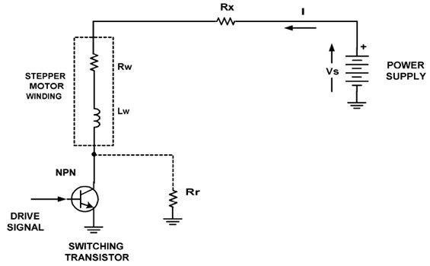

Figure 6.1: Stepper Motor Interfacing Circuit

Defining quantities:

Vs = power supply voltage

Rx = external resistance (Includes that of power supply)

Rw = motor winding resistance

Rr = Leakage resistance across switch

Lw = motor winding inductance

The initial current, when the switch is open is:

I = Io = Vs / (Rx + Rw + Rr)

When the switch is closed, the current will be:

*I* = *Io* + [*V s* ∗ (1 − *e*−*t/T*)*/*(*Rx* + *Rw*)

Where T = time constant = Lw / (Total Circuit Resistance )

This says the current will rise suddenly and gradually approach the value

I = I final = Vs / (Rx + Rw)

After a period of three time constants the current will be about 95 percent of its final value, and after five time constants the current will approach the final steady state value within less than one percent. It is the property of an inductor that the Current cannot change instantaneously in the absence of impulses. Therefore, when the switch transistor turns off, the final current keeps flowing, and flows through a total circuit resistance of (Rx + Rw + Rr), which can be very high. A very high voltage appears across the switch transistor. This could reach several thousand volts, but practical limitations such as stray capacitance and the breakdown voltage of the switch transistor limit this. Nevertheless, the switch transistor(s) must sustain this high voltage.

Note that the current takes time to reach its full value, and this time is decreased for high values of circuit resistance and lower winding inductance. But higher resistance means higher voltages must be used to obtain the necessary drive current. This makes more demands on the switching transistors with regard to voltage breakdown. For short excitation times, the current may not have time to reach the desired value unless special measures are taken. The ability to rapidly.

Turn on and turn off the current in the windings directly affects the rate of stepping That can be achieved for a specified level of performance of the stepper motor. There are two basic drive formats used to drive stepper motors. Unipolar drive uses a bipolar motor winding, with one coil energized at a time, current flowing in only one direction. This does not fully use both windings. At low step rates torque and performance are sacrificed, but the drive circuitry is simplified, since only one Switch transistor per winding is needed. The bipolar format employs a reversal ofwinding current to reverse the stator flux. Current flows in all windings at the same time. Full use is made of the windings, and at low and medium step ratesperformance is improved. However this requires more complex drive circuitry, since a bridge type driver output circuit is required. This is generally an H bridge. See figs for driver configurations. H-bridge IC drivers are available for the power stages that drive the windings. Alternatively, complete IC devices including drivers can be used if preferred.

In addition to these basic formats there are several others that can be used. They are called full step, half step, and mini or micro stepping. They differ in the energization sequence or polarity of the current in the windings, at various times. An illustration of these stepping methods is shown in the figures. Fig XX is simplyone phase at a time, in a 1-2-3-4 sequence. The shaft rotation direction is controlled by the sequence, reversal of which will reverse the direction. The sequence is called wave drive. Since one winding is energized at a time, it consumes the least power. Positional accuracy is good since the rotor and stator teeth are aligned at one time. This is a full step mode, with a step angle of 360 degrees divided by the number of steps per revolution. This method can be used with either unipolar or bipolar drive format. Another full stepping method employs sequentially energizing two adjacent motor phases, in a 1-2, 2-3, 3-4, 4-1 overlapping sequence. This uses two windings at a time and gives a higher torque, better damping, and better immunity to resonance effects. However, it uses twice the drive power since two phases are used at once, and can suffer from imbalance. Any variation in the windings or driver can unbalance the magnetism produced by two adjacent windings, and they may not be exactly equal. This unbalance can cause detent position errors, since the effective pole lies between the adjacent pole positions.

Another method is called half stepping or alternating drive. This method combines the two previous methods, in a 1, 1-2, 2, 2-3, 3, 3-4, 4, and 4-1, yielding double the number of steps as compared to the two previous methods. The wave drive has stable positions when the rotor teeth are aligned, and the overlapping drive has stable positions in between two rotor teeth. This effectively doubles the angular resolution, making 400 steps from a 200 step motor, for example. This produces smoother operation, is quieter, and has better acceleration characteristics.

However, more complex drive and logic circuitry is needed to generate the signals for the switching transistors. For even finer steps mini or micro stepping can be employed. Half stepping uses one or two phases fully excited. If one phase was to be fully excited, and the other only half excited, a new stable position would be generated. If, in the previous sequence, instead od 1 followed by 1-2, we would have 1 followed by 1 plus half 2, then 1-2 , then half 1 plus 2, then 2, and so on. This would yield quarter steps, giving 800 stable positions for a 200-position motor, as compared to using full stepping. This can be carried even further into micro stepping, by varying the drive currents in four excitation levels, giving 8 positions per step, or 1600 total. As one may imagine, this can become quite complex, and more expensive. However, with LSI IC devices, this can be quite feasible. Care must be used in maintaining drive waveforms, as more steps demand more precision as to drive currents, in contrast to the simple on-off requirements of full or half stepping. Single ended stages may be used for unipolar stepper motor drive applications. However, for bipolar applications a dual polarity driver is required. This can be achieved with the H bridge as was shown in the figures. This uses four transistors. Each transistor has a driver included to form Darlington pairs. This structure can easily be made in monolithic form. Q1 and Q3 are PNP, whileQ2 and Q4 are NPN devices. Care must be taken to see that Q1 and Q2 are not turned on at the same time, as this would cause a short circuit across the power supply, with large current spikes. This also applies to Q3 and Q4. In this circuit we have two voltage drops, one in each transistor pair, resulting in a loss of 1.5 to 3 volts of supply voltage, but this is usually not a problem. The use of a monolithic array for Q1 through Q4, including their drivers is a good idea, since it simplifies PC board layout

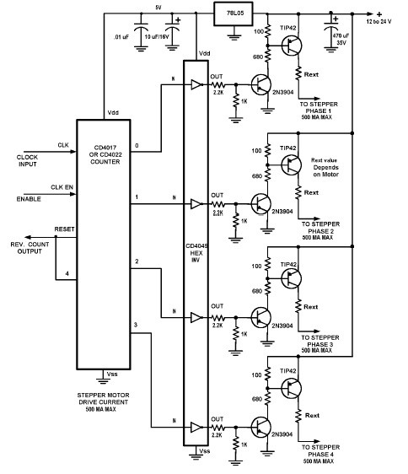

Figure 6.2: Stepper Motor Drive Circuit Full Stepping 4 Phase Unipolar Drive

and eliminates possible transistor matching problems. The design of the driver circuitry is another topic and we will not go into this aspect of stepper motors in this article. Fig XX shows a typical unipolar driver circuit using TIP32 or TIP42 plastic power transistors and a few logic gates. This circuit will drive many 4 phase surplus stepper motors and can be used to experiment with or to test motors you may have already in your stock of parts.

Note also that the waveforms needed can easily be generated using a microcontroller. The microcontroller can also be programmed to perform other necessary functions, such as on-off, positioning, counting, speed control, stepping mode (full, half, etc), speed regulation, and fault protection. The drive waveform(s) can be generated with a routine incorporated into the microcontroller firmware. From the viewpoint of the experimenter, the microcontroller approach has the advantage of programmability for specific applications and is probably the most versatile way of generating stepper motor control signals. Stepper motors are somewhat expensive when purchased new, but you should be able to find used ones on the surplus market.

The throw-away mentality plus the rapid obsolescence and disposal of so much computer and office equipment that is prevalent today should provide sources of usable stepper motors for the experimenter. Check out in particular junked scanners, fax machines, drives, and old copiers, you may find some useful stepper motors for free. You can accumulate a wide variety of hardware and components useful in robotics as well. The stepper motor can be mechanically coupled to a gear train or pulley system to reduce its speed and increase torque, and/or to a cam or mechanical linkage to drive an actuator to do a required task. One such application is a positioning mechanism using a screw thread and a nut.

*6.3 Project*

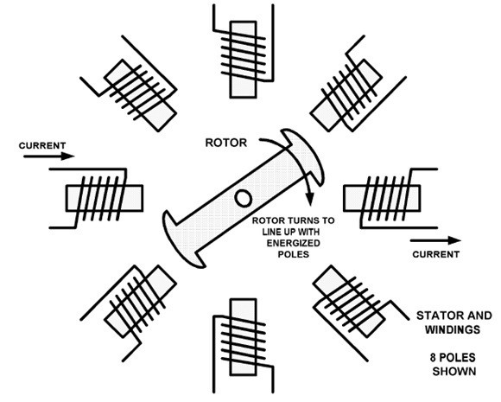

Figure 6.3: Basic Stepper Motor

This drives a cam and linkage that in turn positions an arm. It could also be used to position a video camera or a steering or control linkage. This mechanism is easily assembled from hardware store components, and does not need expensive and often difficult to locate gears. It is shown in fig xx. Some mechanical applications will require speed reduction or translation of motion from linear to rotary, and vice versa. The screw thread and nut will perform a rotary to linear translation, but not the reverse. Linear to rotary translation will possibly require rack and pinion gears, pulleys, or friction drive components such as wheels and belts. Gears are commonly available from surplus houses if you do not have exacting requirements, and also can be obtained from junked machines and appliances.

If you need a specific type and size, they can be obtained from vendors, but be prepared to pay. One can collect many metal and plastic gears from discarded items and appliances, but your projects must be designed around what you have. Another possible method is to use pulleys and belts. These can be salvaged from old equipment as well, and pulleys can also be homemade from wood or plastic, or obtained at hardware stores in various sizes. Friction drive components can also be obtained from junked items such as old cassette and reel to reel tape decks, discarded turntables, and also small appliances. Stepper motors can therefore be used in robotic and other applications in a number of ways and also may simplify those applications needing exact positioning without using positioning sensors and feedback techniques.

# 6.3 Project Circuit

This is an easy to build stepper motor driver that will allow you to precisely control a unipolar stepper motor through your computer’s parallel port. This the main circuit we have used for stepper motor controlling the antenna movement and rotation With a stepper motor you can build a lot of other interesting gadgets such as robots, elevator, PCB drilling mill, camera panning system, automatic fish feeder, etc. If you have never worked with

*6.4 Schematic And How It Works*

stepper motors before you will surely have a lot of fun with this project.

The circuit diagram given below is complex version of the previous circuit but it is most stable one and efficient.

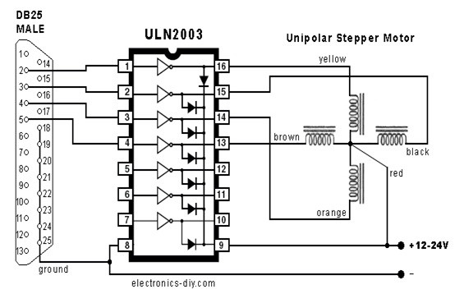

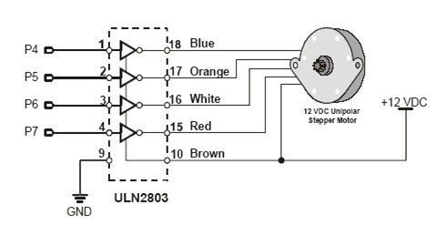

Figure 6.4: Project Circuit Diagram (a,b) Project Circuit Diagram

# 6.4 Schematic And How It Works

For a computer to control a large stepper motor, a switch is needed that will operate from logic level (5 Volt) signals, yet that can control high currents and higher voltages. The International Rectifier HEXFET IRLZ24 is a magnificent power FET that turns on at low voltage (with virtually no current) and acts as low resistances switch handling tons of current! The resistance of the FET is so low that in many applications it requires no heat sinking (especially at higher Motor voltages - go figure!). A FET (Field Effect Transistor) has three legs called Drain, Gate and Source (see drawing). When a sufficiently high voltage is provided to the Gate (as referenced to the Source), power will begin to flow from the

*6.4 Schematic And How It Works*

Drain to the Source. The power consumed by the FET depends on the total resistance from the Drain to the Source. The lower the D/S resistance, the less total power used by the FET. A VGS (the voltage difference between Gate and Source) of 4 volts gives an RDS (resistance from Drain to Source) of 0.105 ohms. By raising the VGS to 8 Volts, the RDS will drop to 0.06 ohms! Note: VGS must not exceed 20 V.

**Chapter 7**

**IR COMMUNICATION**

# 7.1 Infrared

Infrared (IR) light is electromagnetic radiation with longer wavelengths than those of visible light, extending from the nominal red edge of the visible spectrum at 700 nanometres ( nm ) to 1 mm. This range of wavelengths corresponds to a frequency range of approximately 430 THz down to 300 GHz. Most of the thermal radiation emitted by objects near room temperature is infrared.

Infrared radiation was discovered in 1800 by astronomer William Herschel, who discovered a type of invisible radiation in the light spectrum beyond red light, by means of its affect upon a thermometer. Slightly more than half of the total energy from the Sun was eventually found to arrive on Earth in the form of infrared. The balance between absorbed and emitted infrared radiation has a critical effect on Earth’s climate.

Infrared light is emitted or absorbed by molecules when they change their rotationalvibrational movements. Infrared energy elicits vibrational modes in a molecule through a change in the dipole moment, making it a useful frequency range for study of these energy states for molecules of the proper symmetry. Infrared spectroscopy examines absorption and transmission of photons in the infrared energy range.

Infrared light is used in industrial, scientific, and medical applications. Night-vision devices using active near-infrared illumination allow people or animals to be observed without the observer being detected. Infrared astronomy uses sensor-equipped telescopes to penetrate dusty regions of space, such as molecular clouds; detect objects such as planets, and to view highly red-shifted objects from the early days of the universe. Infrared thermal-imaging cameras are used to detect heat loss in insulated systems, to observe changing blood flow in the skin, and to detect overheating of electrical apparatus. Thermal-infrared imaging is used extensively for military and civilian purposes. Military applications include target acquisition, surveillance, night vision, homing and tracking. Humans at normal body temperature radiate chiefly at wavelengths around 10 m (micrometers). Non-military uses include thermal efficiency analysis, environmental monitoring, industrial facility inspections, remote temperature sensing, short-ranged wireless communication, spectroscopy, and weather forecasting.

58

*7.3 Natural Infrared*

# 7.2 Natural Infrared

Sunlight, at an effective temperature of 5,780 kelvins, is composed of nearly thermalspectrum radiation that is slightly more than half infrared. At zenith, sunlight provides an irradiance of just over 1 kilowatts per square meter at sea level. Of this energy, 527 watts is infrared radiation, 445 watts is visible light, and 32 watts is ultraviolet radiation.

On the surface of Earth, at far lower temperatures than the surface of the Sun, almost all thermal radiation consists of infrared in various wavelengths. Of these natural thermal radiation processes only lightning and natural fires are hot enough to produce much visible energy, and fires produce far more infrared than visible-light energy.

# 7.3 IR Communication Basics

Infrared (IR) can be used for line-of-sight communications over low to moderate range. IR is nice because of the lack of interference (except for sun and compact fluroscent lights) and freedom from FCC regulation.

IR radiation is simply light that we cannot see, which makes it great for communication. IR sources are all around us. The sun, light bulbs, or any anything with heat is very bright in the IR spectrum. When use TV remote, an IR LED is used to transmit information to TV. So, how does the IR receiver in TV pick out signals from remote among all of the ambient IR? The answer is that the IR signal is modulated. Modulating a signal is like assigning a pattern to data, so that the receiver knows to listen.

A common modulation scheme for IR communication is something called 38kHz modulation. There are very few natural sources that have the regularity of a 38kHz signal, so an IR transmitter sending data at that frequency would stand out among the ambient IR. 38 kHz modulated IR data is the most common, but other frequencies can be used.

When hit a key on remote, the transmitting IR LED will blink very quickly for a fraction of a second, transmitting encoded data to appliance.

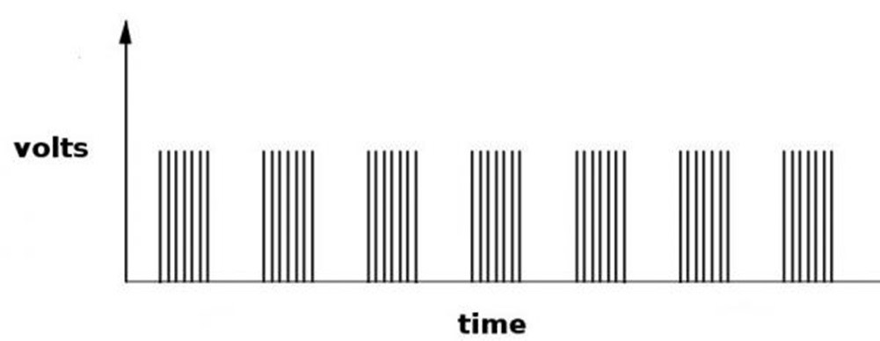

Each pulse is turned on and off at a frequency of 38 kHz

*7.5 Equipments used in our designed*

If we were to hook an oscilloscope up to TV remotes IR LED, we would see a signal similar to the one above. This modulated signal is exactly what the receiving system sees. However, the point of the receiving device is to demodulate the signal and output a binary waveform that can be read by a ic. When we read the OUT pin of the TSOP382 with the wave from above, we will see something like this:

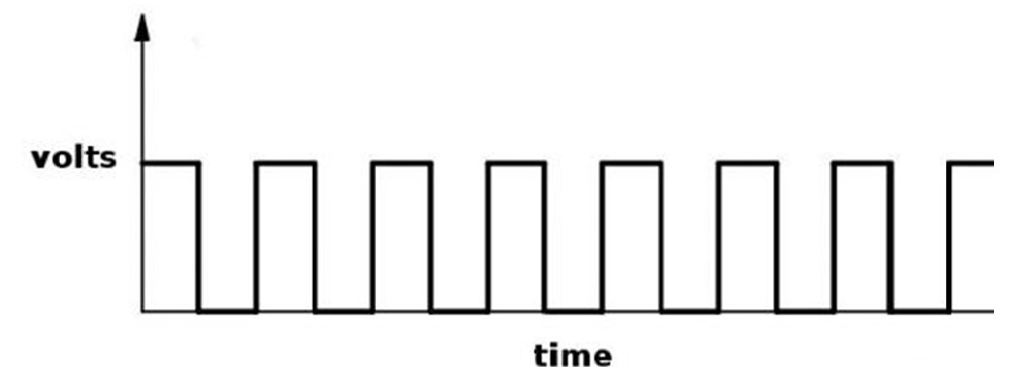

By controlling the spacing between the transmitted modulated signals, the waveform can be read by an input pin on a ic and decoded as a serial bit stream.

Below is conceptual view of how an IR transmitter receiver pair works.

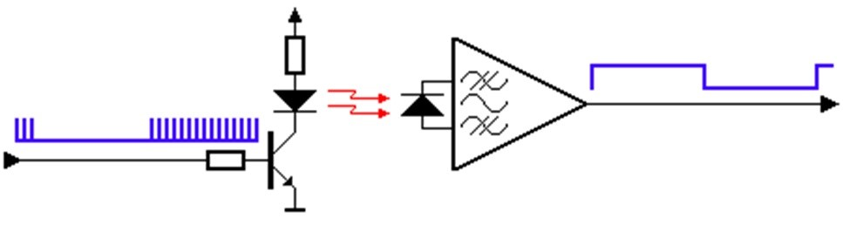

# 7.4 Equipments used in our designed

IR TX (Transmitter), IR RX (Receiver), Power Source (9V), Resistors, 1N4148, S1015, C945, 2N3053,cd 4093, 741, 555.

# 7.5 Transmitter Module

In transmitter module ic cd 4093 generate 38kHz signal which is amplify by transistor and transmitted by IR transmitter LED.

*7.6 IR Receiver Module*

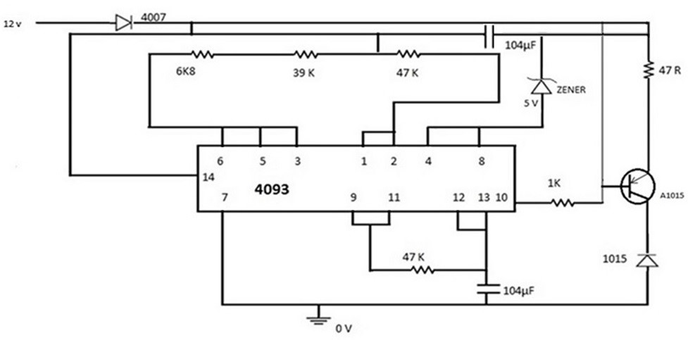

Figure 7.1: IR Transmitter

### CD 4093

The CD4093B consists of four Schmitt-trigger circuits. Each circuit functions as a 2- input NAND gate with Schmitt-trigger action on both inputs. The gate switches at different points for positive and negative-going signals. The difference between the positive ( VTa ) and the negative voltage (VTb) is defined as hysteresis voltage (VH). All outputs have equal source and sink currents and conform to standard B-series output drive.

# 7.6 IR Receiver Module

In receiver module IR receiver LED sense IR signal which is transmitted by transmitter. IC 741 convert the incoming signal in the form of pluse which is apply to the tune generator .

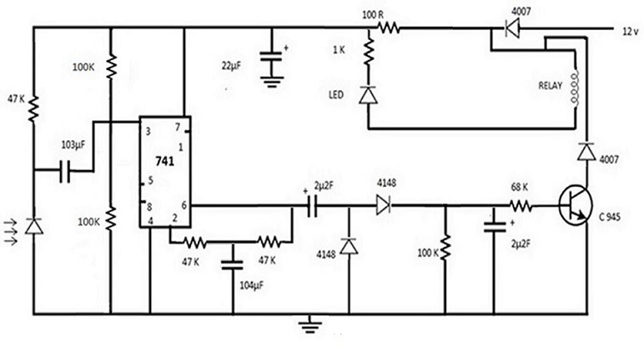

Figure 7.2: IR Receiver

*7.8 C 945 Transistor ( NPN )*

### Pin Configuration of 741

Generally, operational amplifiers are extremely high voltage gain op-amps and they are standard building blocks of analogue circuits. The most commonly used op-amp is IC741. The 741 op-amp is a voltage amplifier, it inverts the input voltage at the output, can be found almost everywhere in electronic circuits. Lets see the pin configuration and testing of 741 op-amps. Usually, this is a numbered counter clockwise around the chip. It is an 8 pin IC. They provide superior performance in integrator, summing amplifier and general feedback applications. These are high gain op-amp; the voltage on the inverting input can be maintained almost equal to Vin. It is a 8-pin dual-in-line package with a pinout shown above.

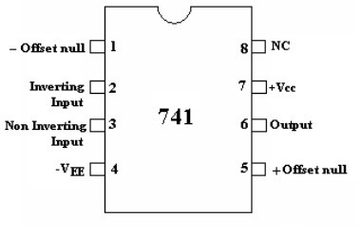

Pin 1: Offset null.

Pin 2: Inverting input terminal.

Pin 3: Non-inverting input terminal.

Pin 4: VCC (negative voltage supply).

Pin 5: Offset null.

Pin 6: Output voltage.

Pin 7: +VCC (positive voltage supply). Pin 8: No Connection.

# 7.7 C 945 Transistor ( NPN )

A C945 transistor is a type of negative-positive-negative (NPN) bipolar junction transistor. Typically, circuits where a low-current, high-speed transistor is required will employ a transistor such as the C945 transistor. Circuits such as a small-signal amplifier or a high-speed switching circuit might employ one or more C945 transistors. A C945 transistor can be used in several types of electronic circuits, but it is best suited for use in low-power applications. Bipolar junction transistors contain three semiconductor regions: the collector, the base and the emitter. An NPN bipolar junction transistor such as the C945 contains a base region that is doped with positive, or P-type, semiconductor material, along with collector and emitter regions that are doped with negative, or N-type, semiconductor material. This configuration allows the C945 transistor to conduct electric current between the collector and emitter regions when voltage is applied to the transistors base region.

*7.9 Tune Generator Module*

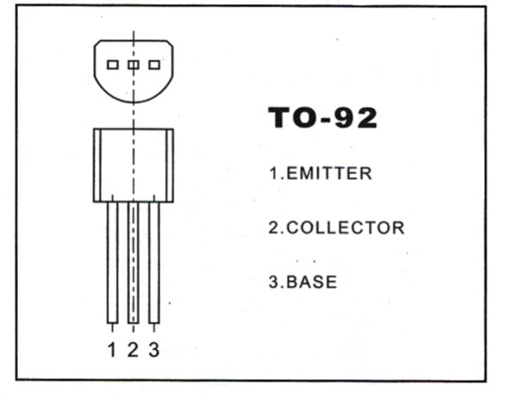

# 7.8 Tune Generator Module

This module simply generate 400 Hz beep when voltage is applied on its input. IC 555 is used to generate tune.

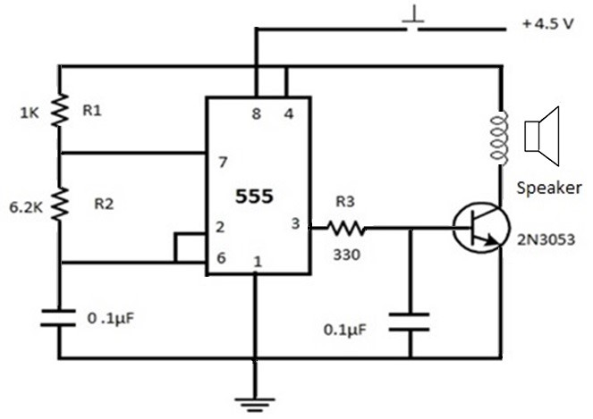

### IC 555

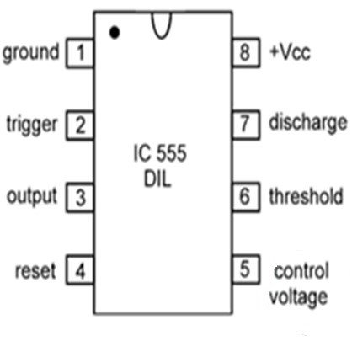

*7.9 Pin-Wise Functioning OF IC555 Timer*

# 7.9 Pin-Wise Functioning OF IC555 Timer

**Pin-1, GROUND:** It is the GROUND PIN of the IC. The negative terminal of DC power supply or battery is connected to this pin. Here note that IC555 works always on single rail power supply and NEVER on dual power supply, unlike operational amplifiers. Also note that this pin should be connected directly to ground and NOT through any resistor or capacitor. If done so, the IC will not function properly and may heat up and get damaged. This happens because all the semiconductor blocks inside the IC will be raised by certain amount of stray voltage and will damage the IC.

**Pin-2, TRIGGER** It is known as TRIGGER PIN. As the name suggests in triggers i.e. starts the timing cycle of the IC. It is connected to the inverting input terminal of trigger comparator inside the IC. As this pin is connected to inverting input terminal, it accepts negative voltage pulse to trigger the timing cycle. So it triggers when the voltage at this pin LESS THAN 1/3 of the supply voltage (Vcc). In number of applications, the IC must be triggered by a pulse. The amplitude and minimum pulse width required for triggering depend on operating temperature and supply voltage of the IC. Generally the current required for triggering is about 0.5uA for a period of 0.1uS. The triggering voltage may be in a range from minimum 1.67V when Vcc=5V to maximum 5V when Vcc=15V. The triggering circuit inside the IC is very sensitive and may be accidently activated due to surrounding noise. To avoid this, the pin is always connected to a pull-up resistor (10kohm), if this pin is used separately.

**Pin-3, OUTPUT** This is the OUTPUT PIN of the IC. It can SINK or SOURCE a maximum current of 200 mA.

Sinking the current means, when the output of the IC is at logic-0 state i.e. LOW and so it can absorb current into its output. Similarly sourcing the current means, when the output of the IC is at logic-1 i.e. HIGH and so it can give out current from its output. Also note that the output voltage of the IC is slightly greater than zero, when it is in logic-0 state. Similarly it is slightly less than supply voltage (Vcc), when output of the IC is in logic-1 state.

**Pin-4, RESET** It is the RESET PIN of the IC. When it is connected to positive terminal of battery, the IC works normally. However, when it is grounded (either directly or through a maximum of 100k-ohm resistor), the IC stops its working completely and its timing cycle stops i.e. the charging or discharging of the external capacitor stops, so output of the IC is locked in logic-0 state. It is interesting to note that the reset voltage required by this pin is typically 0.7V at a reset current of 0.1mA. However in general applications, this pin is always connected to positive terminal so that the IC works normally.

**Pin-5, C. VOLTAGE** This is known as the CONTROL VOLTAGE pin. The 2/3 of supply voltage point on the terminal voltage divider is brought out to pin-5, known as the control terminal of the IC.

The timing cycle can be modified by applying external DC control voltage to this pin. This allows manual or electronic remote controlling of the time interval of the IC.

The control terminal is frequently used when the timer is operated in MMV mode. But if you are NOT using this pin for any such purpose, then this pin MUST BE GROUNDED THROUGH A CAPACITOR OF 0.01uF. This prevents the time interval from being affected

*7.9 Pin-Wise Functioning OF IC555 Timer*

by picking up of stray AC or RF noise from the surrounding. Also note that, when the IC is used as an oscillator, in AMV mode, we can modulate the output waveform of the IC by applying a variable DC control voltage to this pin, as shown below.

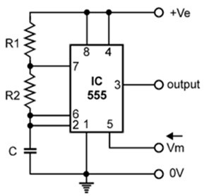

**Pin-6, THRESHOLD** This is known as the THRESHOLD PIN. It finalizes the timing cycle of the IC, when its voltage is equal to or greater than 2/3Vcc, the output is at logic-0 state. Since this pin is connected to non-inverting terminal of threshold comparator inside the IC, it accepts positive going pulse to end up the timing cycle, also.

Note that the typical value of threshold current is 0.1mA, just like the RESET PIN. The time width of this pulse should be greater than or equal to 0.1 uS.

**Pin-7, DISCHARGE** It is known as DISCHARGE PIN. It discharges the external capacitor into itself, but when fully charged It is connected to the collector of an NPN transistor inside the IC. Due to this, the discharging current going into this pin MUST NOT EXCEED 50mA, otherwise the internal transistor may get damaged. It is interesting to note that this pin can also be used as output pin with open collector output. Pin-8, +Vcc It is known as the +ve supply terminal of the IC. The battery voltage connected across this pin and ground pin SHOULD NOT EXCEED 18V. Generally the range of operating voltage of the IC is 3 V18V.

**Chapter 8 CONCLUSION**

# 8.1 Introduction

It is stated that the basic theme of our project is to controlling the position & rection of an antenna using some kind of electrical device which will do the sensing task to intercept the incoming signal, then finding the maximum signal strength coordinates around the 360 circumference. This can be achieved in many possible ways.

# 8.2 Using Simple Motor And Stepper Motor

In this situation we use a simple motor for the rotation of sensing antenna and the signal is captured via sound card of PC. Then the signal is processed and the maximum signal and its direction is find out and then stepper motor is controlled through computer parallel port, to adjust the main antenna in that direction.

This module is mainly consisting of

### 1. Horn Antenna

### 2. Rotatory Motor

### 3. Dual Relays

### 4. Dual Timers

### 5. ON/OFF Switch



Figure 8.1: Sensing Module

66

## 8.2.1 Matlab Code

### The Matlab code for this process is given here

% ========================================== %

%*This code is used to capture Signal for* 360 *degrees* %*Finding the Maximum value out of these* 360 *values.*

% ========================================== %

A=zeros(50,1);

PsC=figure(0Name0,0Automatic Adjustable Antenna0,0NumberTitle0,0off0,... 0Units0,0normalized0,...

0Resize0,0off0,...

0Visible

0Color0,[.4 .5 .9],... 0Toolbar0,0none0,...

0Tag0,0extacy0,...

0WindowStyle0,0normal0) ; p=[0; 0; 0; 0; 0; 0; 0; 0; 0; 0] ; q=[0; 0; 1; 1; 1; 1; 1; 1; 0; 0] ; bar=p;

bar=horzcat(bar,p); for w=1:49 bar=horzcat(bar,q); end bar=horzcat(bar,p); bar=horzcat(bar,p); extacy = imshow(bar); steps=[1 0 0 1;0 0 1 1;0 1 1 0;1 1 0 0] ;

i=1; k=1;

parport=digitalio(0parallel0,0LPT10) ; line=addline(parport,0:3,0out0) ;

AI = analoginput(0winsound0,0); chan = addchannel(AI,1); AI get(AI) AI duration = 1 ; SampleRate = 8000 ; set(AI,0SampleRate0,SampleRate);

set(AI,0SamplesPerTrigger0,duration*SampleRate);

AI AI for j=1:50 start(AI) AI data = getdata(AI); data=data’; s=abs(data); s=sum(s); A(j)=s; extacy = imshow(bar); if j *>*49 title(0Stoped: Programme Ends0,0FontWeight0,vbold0) ; else

title(0Rotation in Clockwise Direction0,0FontWeight0,0bold0) ; end bar(:,j+2)=p pval=steps(i,:); i=i+1; putvalue(parport,pval); gval = getvalue(parport); if i*>*4 i=1; end

tic;

while(toc *<*.2) ; pause(0.001); end end pval=[0 0 0 0] ; putvalue(parport,pval); gval = getvalue(parport); delete(AI); clear AI; delete(parport); clear parport; figure(2); plot(A); signal=A; Max first = signal(1); index = 1 ; for i=1:50 if signal(i) *>*=Max first Max first = signal(i); index = i; x = index end

end

Maximum value = Max first

Angle = x*7.2

% ========================================== %

%*This code is used for move at desire position*

% ========================================== %

PsC=figure(0Name0,0Automatic Adjustable Antenna0,0NumberTitle0,0off0,... 0Units0,0normalized0,...

0Resize0,0off0,...

0Visible

0Color0,[.4 .5 .9],... 0Toolbar0,0none0,...

0Tag0,0extacy0,...

0WindowStyle0,0normal0) ; p=[0; 0; 0; 0; 0; 0; 0; 0; 0; 0] ; q=[0; 0; 1; 1; 1; 1; 1; 1; 0; 0] ; bar=p; bar=horzcat(bar,p); for w=1:50 bar=horzcat(bar,q); end bar=horzcat(bar,p); bar=horzcat(bar,p); extacy = imshow(bar); steps=[1 1 0 1;0 1 1 0;0 0 1 1;1 0 0 1] ;

i=1; k=1; y=50-x z=y+1

parport=digitalio(0parallel0,0LPT10) ; line=addline(parport,0:3,0out0) ; for j=1:z extacy = imshow(bar); if j *>*z

title(0This is the desired position0,0FontWeight0,0bold0) ; else title(0Rotation in Anti Clockwise Direction[j]0,0FontWeight0,0bold0) ; end bar(:,j+2)=p; pval=steps(i,:); i=i+1; putvalue(parport,pval);

*8.3 Stepper Motor Only.*

gval = getvalue(parport); if i *>*4

i=1; end

tic;

while(toc *<*.2) ; pause(0.1); end end pval=[0 0 0 0]; putvalue(parport,pval); gval = getvalue(parport); delete(parport); clear parport;

## 8.2.2 Circuit For Stepper Motor Control

This is an easy to build stepper motor driver that will allow you to precisely control a unipolar stepper motor through your computer’s parallel port. This the main circuit we have used for stepper motor controlling the antenna movement and rotation With a stepper motor you can build a lot of other interesting gadgets such as robots, elevator, PCB drilling mill, camera panning system, automatic fish feeder, etc. If you have never worked with stepper motors before you will surely have a lot of fun with this project.

The circuit diagram given below is complex version of the previous circuit but it is most stable one and efficient.



Figure 8.2: Circuit For Stepper Motor Control

# 8.3 Using Stepper Motor Only.

The simple motor has some delay problem. So to avoid delay problem we may use stepper motor for both sensing and adjustment. But there are still two scenarios **i) Single stepper motor ii) Two stepper motors**

*8.4 Stepper Motor Only.*

We have to make some changes both in circuit and code for each case.

## 8.3.1 Using Single Stepper Motor.

In this case one stepper motor is used for both sensing and adjustment Antenna and provide base for antennas.

The circuit diagram is given below

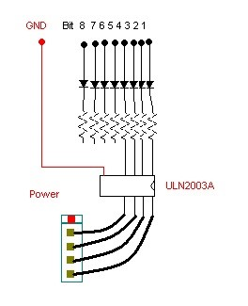

Figure 8.3: Using Single Stepper Motor

Simplified diagram in figure 8.3 is given here which is more practical in the sense that Diodes are used here to avoid back EMF which may damage parallel port of PC. So diodes avoid this back EMF and our PC is secured.

This circuit in figure 8.4 is used when our stepper motor require low voltage for it operation. If the stepper motor can not operate on low voltage then we will have to further amplify the digital pulses and hence another IC of ULN2003A is inserted. The diagram which is given below can be used for both low voltage and high voltage stepper motor by only setting the jumpers.

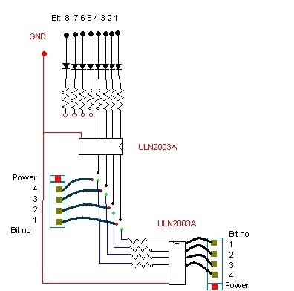

Figure 8.4: Using Single Stepper Motor

*8.4 Two Stepper Motors.*

# 8.4 Using Two Stepper Motors.

In this case two stepper motors are used for sensing and adjustment Antenna and provide bases for antennas.

The circuit diagram is given by here.

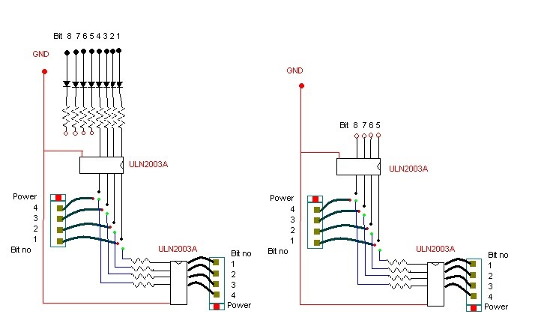

Figure 8.5: Using Two Stepper Motors

This circuit in figure 8.5 is a general purpose circuit which can be used when our stepper motors require low voltage for it operation. If the stepper motors can operate at low voltage only the jumper setting is changed. If the stepper motors can not operate on low voltage then we will have to further amplify the digital pulses and hence another IC of ULN2003A is inserted. However this circuit can also be used for the earlier case when only one stepper motor is used. So this is a multi functional circuit. And we have actually used this circuit.

**Bibliography**

1. Cogdell, J. R., Foundations of Electrical Engineering, 2nd Edition, Upper Saddle River, NJ: Prentice-Hall, 1995.
2. Horowitz, P., and W. Hill, The Art of Electronics, Cambridge, Mass.: Cambridge University Press, 1980.
3. Pozar, D. M., Microwave Engineering, 2nd Edition, New York: John Wiley, 1998. [4] Matthaei, G., E. M. T. Jones, and L. Young, Microwave Filters, Impedance-Matching [5] Networks, and Coupling Structures, Boston: Artech House, 1980.
4. Straw, R. D., Editor, The ARRL Antenna Book, 19th Edition, Newington, Conn.:
5. American Radio Relay League, 2000.
6. Carr, J. J., Practical Antenna Handbook, Fourth Edition, New York: McGraw-

Hill,2001.

1. Kraus, J. D., Antennas, 2nd Edition, Boston: McGraw-Hill, 1988.
2. King, R. W. P., and C. W., Harrison, Antennas and Waves: A Modern Approach, Cambridge, Mass.: The M.I.T. Press, 1969.
3. Heald, M., and J. Marion, Classical Electromagnetic Radiation, 3rd Edition, Fort Worth, Texas: Saunders College Publishing, 1980.
4. Griffiths, D. J., Introduction to Electrodynamics, 3rd Edition, Upper Saddle River, NJ: Prentice Hall, 1999.
5. Vanderlinde, J., Classical Electromagnetic Theory, New York: John Wiley & Sons, 1993.
6. Jackson, J. D., Classical Electrodynamics, 2nd Edition, New York: John Wiley & Sons, 1975.

73

*CHAPTER BIBLIOGRAPHY 8.4 BIBLIOGRAPHY*

# WEBSITES:

1. http://www.anaheimautomation.com
2. http://www.stepperworld.com/
3. http://www.ams2000.com/
4. http://en.wikipedia.org/wiki/Antenna
5. http://www.arrl.org/tis/info/antheory.html
6. http://www.ac6v.com/antprojects.htm
7. http://www.iop.org/EJ/article/17426596/15/1/041/jpconf5 15 041 .html
8. http://www.lvr.com
9. http://www.RobotStore.com
10. http://www.metalworking.com/
11. http://www.kellyware.com/
12. http://www.thegallows.com/stepster.htm
13. http://www.arrl.org/tis/info/antheory.html
14. http://www.ac6v.com/antprojects.htm
15. http://www.iop.org/EJ/article/17426596/15/1/041/jpconf5 15 041 .html

*Project Automatic Adjustable Antenna* 74

1. Resize0,off0,...
2. Visible0,0on0,...
3. Resize0,off0,...
4. Visible0,0on0,...
5. Color0,[.4 .5 .9], ... 0Toolbar0, 0none0,...
6. Tag0,0extacy0,...
7. WindowStyle0, 0normal0) ; p=[0; 0; 0; 0; 0; 0; 0; 0; 0; 0] ; q=[0; 0; 1; 1; 1; 1; 1; 1; 0; 0] ; bar=p; bar=horzcat(bar,p); for w=1:199 bar=horzcat(bar,q); end